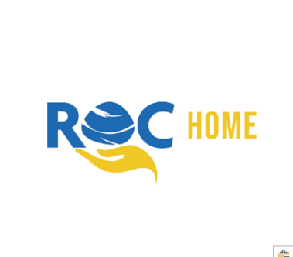



**Statement of**

**Purpose**



Hunthorn

Date of Original Document: 20th November 2018

Date of Issue: 28.11.23



Registered Manager*

Dan White

Contact: [daniel.white@rocgroup.org.uk](mailto:daniel.white@rocgroup.org.uk)

TEL: 01429 733046

Responsible Individual

Laura Roberts

Contact: [Laura.roberts@rocgroup.org.uk](mailto:Laura.roberts@rocgroup.org.uk)

TEL: 01325 310009

Registered Provider:

ROC Family Support Ltd

Hope House

Newton Aycliffe

Co Durham

DL5 7ER

Tel: 01325 310009

Email: [info@rocgroup.org.uk](mailto:info@rocgroup.org.uk)

Web: [www.rochome.co.uk](http://www.rochome.co.uk)

Hunthorn Ofsted Registration Number: 2517184

**\*The Registered Manager must ensure a copy of The Statement of Purpose is on display in the home and that a copy Is given to all residents, parents, team members and social workers involved at Hunthorn**



Contents

Who we are 4

Core values 5

Our aims 6

Hunthorn 7

Placement types & admission criteria 8

Admissions 9

****Emergency admissions 10

About the house 11

Thornley area 12

Equality, diversity & identity 13

Family & friends 14

Having a say 15

Safeguarding 16-17

Emergency safety 18

Security 19

Unauthorised absence 20

Behaviour 21

Physical intervention 22

Education 23

Having fun 24

Health & wellbeing 25 - 26

Team members rota 27

Meet the team 28-32

Audits 33

Big picture 34

Compliments & complaints 35

Complaints contacts 36

Who we are

We started in 1999 with the aim of helping people however we could. We meet the needs of people in the northeast by providing outreach support, supported accommodation, supervised and supported family time and homes for children.

We are passionate about making a difference to the lives of the people we work with and our teams go over and above to make sure this happens. What makes us special? **Our People.** The culture they have created is award winning! Some of our ROC Group accolades include;

* National Care Employer of the Year 2022 (Children & Young People’s Awards)
* National Housing with Care Winner 2022 (GBCA)
* Investors in Children Gold
* CQC Outstanding at 4 Consecutive Inspections
* Ofsted “Good” Provider
* Enhanced National Association of Child Contact Centre’s Accreditation
* 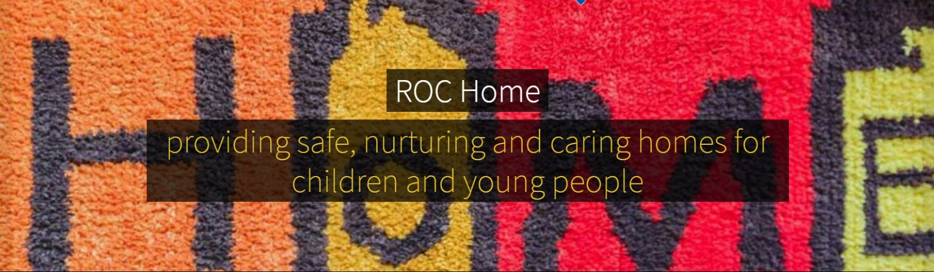IASME Governance certified

*ROC Home Mission Statement 2019*



Core values

As a team we have eight core values, which are very important to us. They run like golden threads through everything we do and how we treat people. They are:

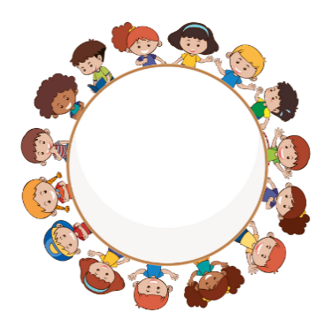

**Equality and diversity**

**Learning and personal development**

**Recognition**

**Safeguarding**

**Listening and consultation**

**Working together**

**The rights of children and young people**

**Integrity, transparency and respect**

Our aims

* To provide a high-quality, residential service which has focus on continuous improvement and quality assurance
* That all homes will offer stability, security and a warm, safe caring environment in which children can positively thrive
* That children and young people are provided with structure and consistency of boundaries
* To encourage expression of views and listen to them, acting on them where possible
* To help children and young people to achieve the 5 outcomes from Every Child Matters:

1. Be healthy
2. Stay Safe
3. Enjoy & Achieve
4. Make a Positive Contribution
5. Achieve Economic Well-Being

* To ensure that the children and young people in our care receive educational support
* To provide therapeutic-based support to children and young people
* To provide consistent and reliable team members who can be “role models”
* To be a positive influence on behaviour, tailoring our behavioural approach to the needs of the person
* To support young people to change behaviours which could impact upon their quality of life
* That children and young people work together to make decisions for the home
* To establish strong links with the local community and build good relationships
* Ensure the cultural and diversity needs of each child are met
* Encourage children and young people to get involved in social and leisure activities and enable them to make positive use out of their free time
* To enable young people to transition to leaving care by supporting them with a range of life skills training
* To promote good communication and effective working relationships with children and young people, our teams and all stakeholders
* Provide team members who have the necessary knowledge, skills and experience required to provide a service delivered to national standards
* Promote family time and positive friendships
* Provide 24-hour telephone support, via an on-call service



Hunthorn

* Hunthorn is a specialist home which provides support for up to three young people, of any gender (dependent on matching) from ages 8-17, who have emotional and behavioural difficulties. Young people will usually stay for several months up to a number of years depending on their individual plan
* Hunthorn has appropriately qualified, inducted and trained team members. Young people are supported on a 3:2 or 3:3 basis by team members working on a rota pattern. Waking nights are not required, although can be put in place as needed
* Children and young people are encouraged to develop safe, stable and secure relationships with adults in the home. As such, we allocate a keyworker to each young person to offer individual support. These workers take an important place as a core member of the team around the child, contributing to planning and decision making.
* The practices at Hunthorn are inclusive and support young people to develop in terms of life-skills and emotional and mental resilience, to a point where they can cope without our support, return home, to another placement or to live independently.
* We believe in equal opportunities for all. Young people will not be discriminated against on the basis of age**,** race**,** religion, pregnancy, gender reassignment, sex, sexual orientation or disability. All team members receive training in equal opportunities and diversity.
* Young people are sensitively supported in exploring their identity, in relation to any and all strands of diversity as appropriate. We actively assist young people where they follow any particular religion, and will forge links with local providers to ensure that any cultural needs in terms of diet, clothing etc are met.
* Hunthorn receives regular consultation from ASPIRE psychological services. Aspire provide advice and support for the team and children and young people. This can range from developing a knowledge base, skills, expertise in understanding complex presentations, reflective practice on behaviours that may challenge.
* The home uses the principles of PACE and positive behaviour support to provide a nurturing environment with a focus on long term outcomes.



Placements

**Placement Types:**

* Solo Placements
* Dual Placements
* Triple Placements

**Admission Criteria:**

Hunthorn is open to up to three young people of any gender aged 8 to 17 years predominantly exhibiting

* Emotional and Behavioural or Educational difficulties







Admissions

We aim to make the young people who come to live at Hunthorn feel ***at*** home.

To help do this, we have an admission meeting which will include the young person and their family, the social worker and representatives from the home (usually the manager and a keyworker).

Information will be shared between all parties, to enable us to care for the young person effectively, and the placement agreement and safety plan will be made and signed.

The child or young person will be shown around the home and introduced to other residents and the team. They will be given a welcome pack, which includes some goodies, and a guide containing information such as fire procedures and how to make a complaint. A keyworker will spend time with them, to help them settle in, and pick which paint colour they would like for their room! On some occasions, there will be several visits, and overnight stays, to prepare the young person for their move



Young people already in the home will be prepared for a new admission by 1:1 keyworker sessions or sometimes young people’s meetings. Appropriate information will be shared with them, to help to minimise the impact of change on them.



Emergency admissions

Admissions will usually be on a planned basis, to make sure the individual needs of all the children and young people in the group are met. The admission process is governed by the needs of the young person, for example sometimes a quicker move may be needed.

On rare occasions admissions may be made in an emergency, where this is in the best interest of the child.

The following criteria must be met:

* The placement is part of a care planning process which addresses the needs of the young person
* The placement will provide the best available method of achieving the aims and objectives of the plan for the young person and will meet the young person’s assessed needs
* The placement is in accordance with the home’s Statement of Purpose
* The home is able to provide levels of care appropriate to the needs of the young person
* The young person’s needs will be assessed in conjunction with the needs of the young person already resident at Hunthorn, and there are no grounds for considering that this placement will significantly impact on any current young person or the young person themselves
* A care planning meeting must take place within 48 hours of the placement

The decision regarding the placement will be based on all of the above, after considering the available documentation, e.g. care plan, assessments, risk assessments, talking with the child/ young person, parents, the social worker and other agencies, if applicable.



About

the house

The home is a 5 bedroom detached property, converted to meet the requirements set out by the Children’s Homes Regulations 2015.

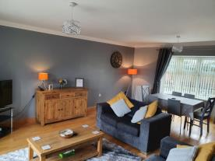Each young person has his/her own bedroom which contains a television. Young people are given a key for their room and there is also lockable storage in their room to keep personal and private things safe. There is also a lounge, den, kitchen with dining table, a utility room, office for team members and the manager with sleep in facilities for team members, 3 bedrooms for young people, 1 team members sleep in room, 2 bathrooms,1 en-suite for team members, 4 toilets in total, and a spacious paved/decked area outside.

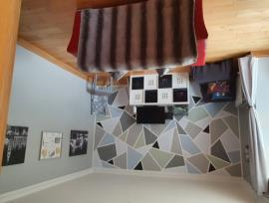

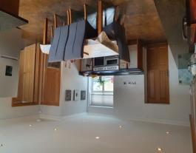

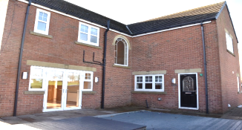

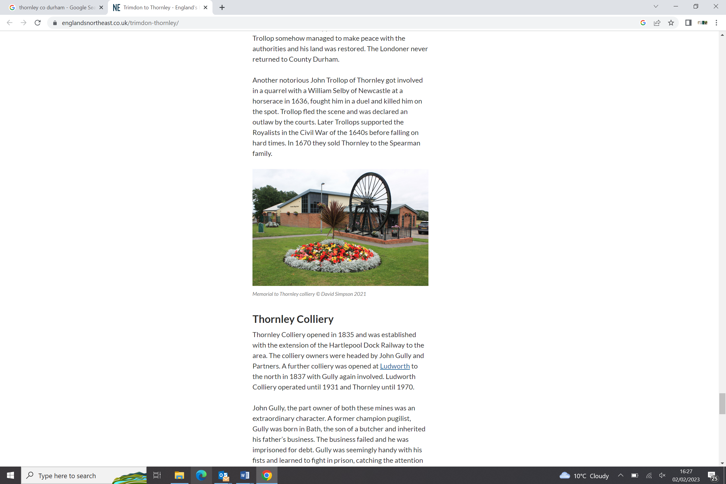

The local

area

We are situated in the heart of Thornley village, close to a local corner shop, library, village community centre and next to several public field areas.

There is a bus-stop just outside the property, with routes which go into Sunderland and across Co Durham.

Young people can access cinemas, theatres, play areas, climbing walls, leisure centres, gyms, sports clubs and shops by public transport. Other attractions include Hamsterley Forest, Hardwick Park, Auckland Castle, various horse-riding centres, Beamish Museum and Lightwater Valley theme park.

There are local primary schools, in Thornley and Wheatley Hill and a secondary school in Wingate which is a 10-minute drive from Hunthorn.

Hunthorn has it’s own car to help children and young people access the local area and team members are also able to use their own cars.

**The Thornley Community**

At Hunthorn, we are building relationships with the Thornley Community. The senior team are committed to getting involved with the community and local charities.

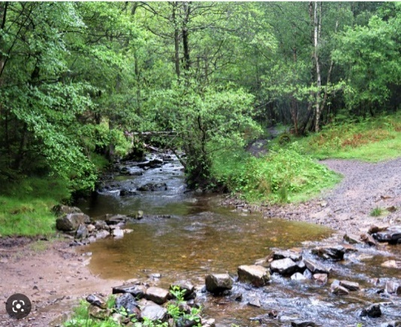





Equality

&

diversity

Hunthorn provides a learning, working and social environment where the rights and dignity of all are respected, which is free from discrimination, prejudice, intimidation and all forms of harassment and bullying.

We are proud to be diverse and inclusive, where individual differences are accepted and valued, and where everyone is able to fulfil their potential. The home is opposed to all forms of discriminatory behaviour.

We believe that all young people, visitors and team members are entitled to respect and to live and work in a welcoming, safe and non-threatening environment.

Any complaints of discrimination or harassment will be treated seriously, be fully investigated and any appropriate action taken by management.

We are strong advocates of children’s rights, and where a young person’s views are not being heard, we will offer the support of an independent advocate to support them.

As part of the admissions process, we will make enquiries about a young person’s religious beliefs (if any) and discuss with them and their parents/carers the arrangements which need to be made to enable the young person to follow their religion e.g. adjustments to menus, facilitating attendance at religious festivities etc. We will also ensure that the necessary arrangements are in place to meet a young person’s cultural needs such as traditions.

Family

& Friends

The team at Hunthorn help to maintain and support relationships between young people and their families and friends in as positive a way as possible. We recognise how important this can be in their overall progress and development. Family time arrangements will always be discussed as part of the admission process and can be facilitated by our team. This will include who can give permission for overnight stays with friends and family which then forms part of the Placement Plan. Any known restrictions will be made clear and will also be included in the Placement Plan. These will be fully explained to the child/young person.

Children and young people will be provided with practical support for family time with parents, families, and other significant people. This may include transport, telephone calls, e-mails etc where it follows their plan of care and is safe to do so.

We will provide families with regular feedback, in a format agreed with them, regarding the child/young person’s progress. We aim to include them in as many decisions as possible where it is appropriate.

We try to ensure that young people maintain healthy relationships. Time with established friends will be promoted wherever possible, encouraging friends to visit the home where this is appropriate. We will support them in making new friendships, where appropriate. Plans will take into consideration the age and vulnerability of the child/young person and identify where some supervision is necessary to keep them safe, for instance regarding access to social networking sites.

Parents and other relatives will be made welcome. Family members will be offered refreshments. Records will be kept in the visitor’s book and in the child/young person’s file recording the date, time and length of visit. A child or young person will be allowed the right to refuse to see a relative, if they so wish. In the event of this occurring with a child under the age of 16 years, where mediation is unsuccessful, further advice will be sought.

The team will adopt a restorative approach if there are difficulties between young people and their family or friends, to try to resolve the situation.

Wherever possible, any decisions about children/young people will be made in consultation with their parent/family.

Any serious incident, e.g. accident, illness, injury, or if the child/young person is missing, will be communicated, wherever possible, with parent(s) immediately or in accordance with pre-agreed plans.

Having

a say

We know that nothing is more effective than forming positive, open relationships with children, young people and their families where individuals feel empowered to put forward their honest opinions.

We want children and young people to be involved in running the home. We care about their and their parent’s views on issues to do with the running of the home.

Monthly, recorded house-meetings are held, where children and young people can set their own agenda, and help with decision making about aspects of the home, for instance; holidays, decoration, activities etc. Key working sessions can serve the same purpose for those who find it easier to pass on their thoughts one-to-one or struggle to express their feelings in a group.

Their views are recorded in Charms (online system), for example, regarding bullying, any restraint, consequences of actions etc. The Registered Manager will use this information as part of their monitoring of the home under Regulation 45 of the Children’s Homes Regulations 2015.

Views are regularly sought from parents and social workers about the care that young people receive at Hunthorn. As well as obtaining this verbally, we also send out quarterly feedback forms to families and professionals involved in the child/young person’s life. We try to use this to improve what we do. We are proud to have been awarded Investors in Children Gold status, which demonstrates our commitment to listening to feedback and acting on it.

****As part of Regulation 44 of the Children’s Homes Regulations 2015, an independent visitor from National Youth Advocacy Service (NYAS), comes to the home and provides a report of their findings which is then shared with the management of the home and Ofsted. One of their tasks is to spend time talking to children/young people to form an opinion about the quality of care we provide. Ofsted also seek the views of children/young people, families and social workers as part of their inspection process.





Safeguarding

Hunthorn is subject to the Durham Safeguarding Procedures. All team members undertake safeguarding training and are made familiar with these procedures. Safeguarding refresher training is available via e-learning courses.

We use safer recruitment processes in line with Durham Safeguarding Children Partnership, (DSCP), and practice safe care procedures. We also have lone working policies and procedures to safeguard everyone involved.

We have created an open culture, where team members and young people are able to discuss any concerns of a child protection nature, without fear of consequences. We encourage speaking out about concerns around practice, where it is felt that it cannot be dealt with through normal routes, or they are of sufficient seriousness, to warrant bringing to the attention of the Responsible Individual or Directors.

Team members can often be the first to realise that there may be something wrong within the organisation, but they may not feel comfortable expressing their concerns, as they might feel that “speaking out” would be disloyal to colleagues, managers or the organisation.

In instances of team members allegations, we will ensure that the Local Authority Designated Officer has been informed.

Team members will be trained to know how to report immediately any abuse, or suspicions of abuse whether this has taken place inside or outside of the home. This is covered within our Whistleblowing and Safeguarding policies.

Children and young people are advised on what to do if they are being hurt or abused in any way. They are provided with our Guide which has numbers for NYAS, Ofsted, and Child-line etc. They will have access to a telephone which they can use without supervision, unless it is not appropriate.

As part of key working sessions, we will discuss with young people their rights and how to pass on compliments and complaints.

Hunthorn has a policy on countering bullying which is reviewed annually. These policies include identifying bullying, addressing bulling and how to support victims and perpetrators of bullying. Key workers talk to young people about bullying and how to stay safe.

All child protection incidents are recorded according to Durham Safeguarding Children Partnership procedures, and cross referenced within the homes’ electronic database (Charms).

We make it our business to understand what is happening in the local community, working closely with neighbourhood police, to pool information in order to keep young people safe. We record any known risks in a locality risk assessment and review this as required, to keep the information current.

The Registered Manager is the lead person in the home to take responsibility for overall safeguarding issues.

Our full child protection policy can be obtained by contacting Lynn Cunningham on 01325 310009 or Info@rocgroup.org.uk.



| **Name of**  **Local Authority / Gov Agency** | **NAME** | **website/ADDRESS** | **EMAIL** | **TELEPHONE** |
| --- | --- | --- | --- | --- |
| **Durham** | **First Contact Service** | <https://www.durham-scp.org.uk/> | [scd@durham.gov.uk](mailto:scd@durham.gov.uk) or  [firstcontact-gcsx@durham.gcsx.gov.uk](mailto:firstcontact-gcsx@durham.gcsx.gov.uk) | 03000 26 79 79; Fax: 0191 383 5752; Minicom:0142 988 4124  Emergency Duty Team  03000 267 979  Text:  0778 602 7280. |
| **Safeguarding Adults** | http://www.safeguardingdurhamadults.info/ |  | Call: 03000 267 979 |
| LADO | County Hall Durham | [lado-gcsx@durham.gcsx](mailto:Yvonne.davies@durham.gov.uk) | 03000 268 835 |
| **Ofsted** |  | Ofsted Piccadilly Gate Store Street Manchester M1 2WD | whistle.blowing@ofsted.gov.uk  enquiries@ofsted.gov.uk | 0300 123 3155 |
| **Police** |  |  |  | 101 non emergency  999 emergency |

Emergency

safety

* All team members receive training and guidance around health and safety, which includes fire safety. This is regularly reviewed and updated. The Registered Manager audits and monitors health and safety within the home.
* We comply with guidance provided by the Health and Safety Executive, (HSE), and local fire authority, to keep children, team members and visitors safe. All young people are given information about what to do in the event of a fire, when they first visit the home.
* Risk assessments are carried out and recorded in writing on our data base. The Registered Manager will regularly review the implementation and effectiveness of actions identified.
* The Registered Manager ensures that Hunthorn’s fire procedures are adhered to. This includes ensuring that regular fire drills are carried out, including in the hours of darkness, and all children and team members know the emergency evacuation procedures for the home, in the event of a fire.
* The Manager and team members will make sure that Hunthorn, its premises, equipment, furnishings and fittings are physically safe and secure and that any defect is promptly remedied.
* The local environmental Health Service assess the food storage and preparation provision of the home and will be consulted as required if any concerns are raised.
* ROC Home has an Emergency Contingency Plan which will be implemented if required for any major crisis. The on-call rota operates 24/7. The duty worker will work with team members on duty in the home to seek the best resolution for residents, should a serious situation arise. This could include transfer to alternative ROC properties, or hotel accommodation



Security

Our home has in place security systems which ensure that the home, the people who live there, and its contents are kept safe. This includes locking certain doors, throughout the day/evening/night, in such a way that does not prohibit team members or young people from leaving the premises, but denies access from outside. On some occasions, internal doors may be locked for specific health and safety reasons or for issues of confidentiality.

There is an alarm system and door alerts fitted which may be activated at certain zones to screen any unwanted access or movement around the home. This is solely intended to protect the interests of the people within the home. It is not intended as a tool for monitoring the movement of individuals, but is intended to maintain the safety of young people.

Young people also have a lockable safe for their valuables and bedroom door keys.

This list does not include any system of tagging etc imposed by a court or prison authority as part of Youth Justice Board actions.



Unauthorised

absence

Sometimes staying out late happens because children and young people may be having fun with their friends, but sometimes this isn’t a safe thing to do. Children and young people who are absent from our home, without consent, are protected in line with The Police and Durham County Council’s joint written policy and guidance on Children who go Missing from Home or Care. This policy is consistent with national legislation.

To help prevent non-agreed absence, and to protect them if they do not return, we:

* Go out and look for them, if we have any idea where they may be
* Contact friends and family to find out if they know their whereabouts
* Work hard to build positive relationships with children and young people and engage them in pro-social activities, within the community to promote confidence, self-esteem and a sense that this is their home
* Support their friend, family and social networks, unless we have grounds to believe this is not in their best interest
* Provide guidance about relationships appropriate to their age and understanding
* Ensure that where a child/young person has a history of going missing, this will be reflected in the safety plan, along with how we aim to keep them safe, whether they are missing or absent from their designated proper place.
* Share all information with the police and Emergency Duty Team (EDT), in a timely way to ensure that there is a multi-agency response to the individual needs of the child/young person who is missing, particularly if risks are high
* Arrange an independent Return from Missing interview
* Document, report and record incidents of absence from the home, and discuss in Service Performance Meetings and quarterly Board meetings to establish trends and design mechanisms to prevent further absences

Where a specific risk is identified, or the child has been missing several times, we take part in multi-agency meetings with the police, and members of the care team, to make sure our safety plan is robust and we are working together to minimise risk.



Behaviour

We use Positive Behaviour Support to improve the quality of life of our children and young people, increase their positive behavioural repertoire and teach new skills. We use functional assessments where necessary to determine the reason behind the behaviour and develop strategies which motivate the child/young person to change their approach to having their needs met.

* We respond positively to positive behaviour
* We share and acknowledge good behaviour
* We work on rewards, rather than punishment
* We use our positive relationships with young people to deal with issues in a restorative way

**Learning Lessons**

There are some sanctions which are not allowed under The Children’s Home Regulations 2015, for example withholding food or drink or medicine. To see a full list of prohibited sanctions, visit <http://www.legislation.gov.uk/uksi/2015/541/regulation/19/made>

* If a sanction is necessary, we try to negotiate something suitable within a range of acceptable disciplinary measures.
* Sanctions could include the repair of an item broken or financial contribution to the item being fixed. Sanctions should where possible be related to the incident so that the child/young person can make the connection with the consequence.
* Young people’s views of any consequence of action are recorded in our database (Charms) for this purpose, and its effectiveness is monitored.
* Our home has a policy on behaviour management including an additional policy on the use of restraint and restraint reduction.

Our full behaviour management policy can be obtained by contacting Lynn Cunningham on 01325 310009 or [Info@rocgroup.org.uk](mailto:Lynn.Cunningham@rocgroup.org.uk).

Restrictive

intervention

A focus of our team members development programme is to help team members understand how best to work with those who display a range of complex behaviours. Positive Behaviour Support focuses on using restrictive interventions as a last resort to keep people safe and use strategies only where there is the data to support their use. In addition, we receive support where required from Child and Adolescent Mental Health Services, (CAMHS) and Local Authority social workers. This reduces the need to use physical intervention in the home. As a safeguarding measure, however, all team members are trained and refreshed regularly in Positive Behaviour Management, which includes techniques in deflection, distraction and de-escalation, breakaway’s and low-level restraints where there is a need. Their competence is assessed by the trainer and any issues fed back directly to the Registered Manager who will make a decision about their fitness to be involved in restrictive interventions. Each child/young person has a Positive Behaviour Support Plan which details the function of behaviour and strategies at each level of the Time Intensity Model. As a general rule, restrictive intervention will only be performed to keep people safe or where there may be significant damage to property.

Where restrictive interventions are used, this is recorded on an electronic data base, and young people are asked to include their views about the event. They will be given the opportunity, via a life space interview, to discuss the incident and agree ways in which situations could be better handled, if they were to arise again. Their social worker, family and Ofsted will be informed. Documentation will include who performed the restrictive intervention, which technique was used, how long it lasted and whether any injuries were sustained and/or medical intervention was required.

The use of physical intervention, and documentation, is closely monitored within the home by the Registered Manager and ROC Group’s Positive Behaviour Support team. Where it is has been necessary to use physical intervention more frequently to keep young people or team members safe, advice will be sought from outside agencies, such as CAMHS, to ensure that we are working in the best interest of that child/young person.

If you would like to see a copy of our behaviour management policy/restraint reduction policy please contact by contacting Lynn Cunningham on 01325 310009 or Info@rocgroup.org.uk.





Education

We are committed to improving the life-chances of every person who lives with us. Education is a very important part of this outlook. Education will be given a high priority at planning meetings. A multi-agency decision will be made about the viability of maintaining the young person’s current school placement, as part of the admissions process, which will include the young person’s and families’ views.

We work closely with Looked after Children’s Educational Services, (SEND), who allocate a keyworker to all our young people of statutory school age. They help us to monitor attendance, educational progress, and are part of our team around the child.

Keyworkers work closely with the Designated Teacher and Form Teacher within the young person’s educational provision. We aim to ensure that there are excellent channels of communication, so that the young person can see that we are working together to help them achieve their full potential.

We will share information with them to identify barriers to learning. Keyworkers will attend certification days, open days, sports days, etc, and will ensure that educational achievements are suitably celebrated. The team strive to ensure that all young people are supported to continue their learning outside of their education placement. We actively seek educational experiences for young people to enhance learning.

For young people outside of statutory education, keyworkers ensure that appropriate services are accessed to assist them in finding and sustaining suitable training or employment opportunities.

Hunthorn adopts a culture whereby attendance at school, training or work is the norm. This is supported in the education policy. The team support education by providing materials, supporting young people with homework and helping them to prepare for their studies the following day.

Promotion of education, specific school subjects and work placements will not be limited by assumptions about traditional gender roles.



Having

fun

Every child and young person have the right to have fun!

We understand how exposing young people to a range of leisure experiences and activities can improve self-esteem and support learning and development. With this in mind, young people are encouraged to participate in hobbies, clubs and activities. Our aim is to help young people access activities within the community which they can continue into adulthood.

Keyworkers will find out from young people what leisure pursuits they enjoy, and what they are good at, and facilitate the continuation of any hobbies. Young people will be given the opportunity to participate in the activities they wish to pursue, which encourages the development of creative skills e.g. painting, poetry, and music, as well as sporting and physical activities. Team members will participate in these activities, where appropriate, to provide encouragement and support.

The home has a wide range of puzzles, craft equipment and games. We will normally have games consoles and a computer for the young people to use for leisure and home study purposes (which will always get priority over game playing!). It is linked to the internet which can be used with supervision as dictated by a young person’s risk assessment.

The children’s homes team members will consult with young people about the provision of opportunities, which promote the development of cultural and artistic needs, and plan for such opportunities will be done at both a group level i.e. in young people’s meetings and in key-working sessions and planning meetings.

The issue of parental consent will be considered for activities which are provided outside the children’s home i.e. leisure centre, youth club etc.

Our young people benefit from Durham County Council schemes to encourage children to become involved in sport and leisure activities, meaning that many of these can be accessed free by use of the council’s swipe card process.

We also take the young people at Hunthorn away on holiday for a maximum of 14 nights throughout the year, normally within the UK.

Monthly “ROC Stars” events are in place which are directed by the young people and include trips, activities and events.  The agenda and planning are led by the young people who attend.  This group provides a forum for listening to the young people and their ‘voice’ is used to shape the service delivery of ROC Group.





Health &

wellbeing

Our team are focused on helping the young people in our care be healthy and happy. At Hunthorn, we have a health champion who promotes healthy objectives and supports our young people to take care of their health. This could include going shopping together for healthy food and then making recipes together, gaining access to local gyms or motivating the young person towards a health goal.

Public Health England reports that 60% of Looked After Children have some form of emotional or mental illness. We work to provide stability for young people, so that they can be supported to navigate these issues. We undertake direct work with the young person, but also provide support and training for our team where a young person’s needs are particularly complex, or where the child is not ready to engage with services. We also utilize provisions such as our local CAMHS team who are at hand to offer help and advice to team members as well as supporting young people with their mental health needs.

The team members team are trained in substance misuse and have made links with County Durham drug and alcohol services to remain informed on current drug use trends in the region.

Young people, on admission, are always registered as a matter of urgency with a local G.P., a dentist and an optician of the child’s choice if possible. We have designated members of the team who take a lead role in health and attend health representatives’ meetings, and filter information throughout the team.

Young people will be encouraged to undertake regular health checks to monitor progress in this area and to help us assess the effectiveness of our approach, along with our health colleagues, including the Looked After Nurse.

Keyworkers will work closely with families and other agencies to ensure that our health information is comprehensive, and health targets will always form part of the Placement Plan for each young person. These targets will be evaluated and reviewed to ensure health plans are making a difference to the young person.

Team members also have links to the local pharmacy who will advise us on safe storage and disposal of medication as well as a range of health issues. Training can be accessed by team members from the Looked after Nurse and other health professionals. Where a young person has specific health needs, advice and training will be sought from a relevant specialist.

Part of our role is to provide guidance and advice around health issues. We will actively discourage smoking, alcohol and substance misuse and ensure that young people are aware of health risks associated with these actions. We have team members trained to give age appropriate guidance around sexual health and relationship matters, and will always provide this for young people. We will also give general advice and support around how to maintain a healthy lifestyle, and will encourage young people to eat well and exercise. Where any of these issues are a concern for an individual young person, specific targets will be included as part of the Placement Plan, and help from other agencies may be sought.

Team members will not smoke in the presence of young people or consume alcohol while looking after children and young people.

Where required, specialist advice will be sought to provide for the needs of children and young people from minority ethnic and cultural groups, or where a young person has a particular health issue, disability or condition.

We will always check that health professionals have appropriate qualifications and experience, if they are not employed by the local authority.

All team members are trained in paediatric first aid. We also have a core of team members who have undertaken ‘First Aid at Work’ training, or equivalent. A designated first-aider will be identified on each shift.





Team

Rotas

The team members work a variety of duties which, full time, equate to 40 hrs per week over each month. The manager works flexibly throughout the week in order to observe practice for all team members and manage the home during different aspects of day to day life.

The intensity of team cover depends upon the number of children residing at the home, at a given time, and the assessed risks for each child. For example, if there are three residents there will be two or three team members working with them with the additional oversight of the Registered Manager at varying times of the day. Overnight there will be two team members on duty, this may be one sleeping and one awake, or both sleeping depending on safety plans. There are eight full-time team members members employed to cover the care of the young people, as well as the Registered Manager. If there is a need to increase team levels, we have a pool of appropriately recruited, qualified, trained and experienced team members from our other ROC Group services who are able to accommodate any extra requirement. A rota is available to be viewed to see who is on duty at any time.

A lone working policy is in place in the home. Team levels are regularly reviewed as part of the risk assessments of individuals and groups of young people. Rota’s may be altered to suit the varied needs of our residents.

Additional cover, where a member of the team is absent due to sickness, or where there is an identified need to increase team members to support safety plans, will be covered wherever possible by The Hunthorn team, this will achieve continuity of care. When this is not possible the manager will endeavour to use team members from other ROC Group services that are known to the children/young people. Agency will only be used when all other avenues have been exhausted.

All activities will be risk assessed and team members allocated accordingly. Where activities are provided by an external agency, we will consider whether residential team members need to support them, and ensure that risk assessments are undertaken.

Rotas, where practicable, will show a mixed gender of team members. Where this is not possible, for anything other than a short period, we may consider, depending on the views of young people, swapping team members with other homes to maintain a gender balance. There may be occasions where the child’s safety plan indicates that only female or male team members can be used. The duty rota will show which team members and young people are sleeping at Hunthorn each night.

Housekeeping will be on a rota to complete tasks on a flexible basis, to meet the needs of the young people. Cooking and domestic chores will be undertaken by the residential team members, with children and young people encouraged to contribute.

In the absence of the Registered Manager, the residential worker on duty will assume overall responsibility for the home. There is also a Duty Manager system in place which provides Managerial support to team members by telephone, 24 hours a day 7 days a week.

Meet

the team

We are proud of the team we have caring for children and young people. Team members receive regular training, monthly supervision and support to enable them to be the best that they can be for the people in our care. Team members are “champions” of an area to do with home life, for example, a champion of activities. Here is a little introduction to the people working at Hunthorn:

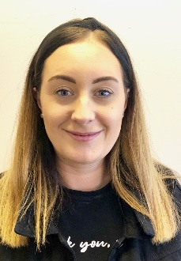Laura Roberts – Responsible Individual

Laura has worked in a residential setting since 2013 and in that time progressed to deputy manager, Registered Manager and now Responsible Individual. Laura is passionate about providing a home that is nurturing where children can thrive and achieve the best outcomes they can.

Qualifications: Level 5 in Leadership and Management in Health & Social Care, Level 3 in Residential Childcare,

Training: Restorative Justice, Mediation & Restorative Practice, Understanding Depression & Suicide, Risk Management and Safer Caring, Reporting and Recording, Infection Control, Emotional Wellbeing and Communication, Child Sexual Exploitation Advanced Level, Suicide Prevention, Certificate Water Safety Management, Dealing with Bereavement and Loss, Medication Advanced, Paediatric First Aid, Psychoactive Substances, Radicalisation and Extremism, Safer Recruitment, Substance Misuse, Personal Care F2F, Anti-Bullying, Internet Safety Children's Homes, Quality Standards, Moving & Handling F2F, Leading and Managing Staff Advanced Level Children's Homes, Managing Allegations Children's Homes, Professional Boundaries in Social Work Children's Homes, Supervision, Appraisal, and Managing Staff Children's Homes, Working with Disabled Children Children's Home, ADHD & Austism Advanced, Moving & Handling Evaluation, An Awareness of Type 1 Diabetes in Schools & Other Settings - Advanced Level, Safeguarding Children & YP with SEND, Ligature, The Signs of Safety Model Workshop, Restorative Practice, Internet Safety Childrens Home, Managing Behaviours Of Manipulation In Looked After Children Children Services, Food Safety and Hygiene Advanced, Medication Advanced, Infection Control, GDPR, Attachment & Bonding, Mindfulness, Child Abuse & Neglect Children's Homes, Bullying & Harassment for Employees, Children and Domestic Abuse, Child Abuse & Neglect, Children & Domestic Abuse, Criminal Exploitation & County Lines, Drugs & Alcohol Awareness, Effective Team Leadership, Duty of Care, Managing Performance, Equality & Diversity Advanced, Health & Nutrition, Lone Working, Female Genital Mutilation, COVID-19 Where Are We Now, PBM Yearly Refresher Course, Complex Trauma, Depression & Suicide, Fire Safety, Food Safety & Hygiene Advanced, GDPR, Health & Safety Advanced

Dan White - Registered Manager

Dan has worked with young people and families for 12 years in lots of different settings. He started working in sports coaching and has worked in residential homes, early help, specialist education, youth offending, family work and in an edge of care provision. Dan has also worked alongside childrens homes in statutory visits (Reg 44), monitoring them and helping them develop. Dan has now joined Hunthorn as manager and is looking forward to helping the young people here progress, enjoy and achieve.

Qualifications: Level 5 Diploma in Leadership and Management for Residential Childcare, Level 5 in Youth Justice Effective Paractice & NVQ level 3 in Children and Young people.

Training: Anxious About School, Attachment & Bonding, Leading and Managing Staff, Missing From Care Advanced, Reflective Practice & Managing Stress, Health & Nutrition Advanced, Internet Safety Advanced Level Childrens Homes, Health & Nutrition Advanced, Female Genital Mutilation, Children & Domestic Abuse, Child Abuse & Neglect, Duty of Care, LGBT F2F, Managing Performance, Risk Management & Safer Caring, Effective Team Leadership, Transgender Diversity Awareness, Mindfulness, Medication Advanced, Reporting, Recording & Incident Training, Reporting, Recording & Incident Training Evaluation Form, Personal Care F2F, Key Work Role & Plans, Key Work Role & Plans Training Evaluation Form, The Core Philosophy Foundation Seminar, Attachment & Bonding, Legionnaires, An Awareness of Type 1 Diabetes in Schools & Other Settings Advanced, An Awareness of Type 1 Diabetes in Schools & Other Settings Basic, Reporting & Recording Advanced, Risk Management & Safer Caring, Supervision Appraisal & Managing Staff, Equality and Diversity, Professional Boundaries in Social Work, Quality Standards, Safer Recruitment, Trauma, Working With Disabled Children, Child Sexual Exploitation Foundation (CSE), Criminal Exploitation & County Lines, Drugs & Alcohol Awareness, Lone Working, Radicalisation & Extremism, Personal Care F2F, Paediatric First Aid F2F, Competency Framework Workshop, Ligature, Moving & Handling, Moving and Handling F2F, Referrals and Admissions, Anti-Bullying, Depression and Suicide, Infection control, Managing Allegations childrens homes, Medication Advanced, Mental Health childrens home, Food Safety & Hygiene Advanced, Health and Safety Level Childrens Homes, Fire Safety, Covid 19 Where Are We Now?, Positive Behaviour Management (PBM), GDPR

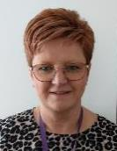Allison Swainston – Deputy Manager

Allison has worked with children since 2005 and worked in a residential setting since 2010.

Qualifications: Level 3 Health & Social Care Children & Young people, Level 5 Diploma in Leadership in Health & Social Care Children & Young People, Level 3 Teaching Assistant,

Training: Criminal Exploitation County Lines, Depression Suicide, Attachment & Bonding, LGBT Awareness F2F, Personal Care Evaluation, Legionnaires, Female Genital Mutilation, Understanding Autism, Attachment & Bonding, An Awareness of Type 1 Diabetes in Schools & Other Settings : Basic Level, Reporting And Recording Advanced Level Children's Homes, Working With Disabled Children Children's Homes, Infection Control Children's Homes, Internet Safety Children's Homes, Drugs & Alcohol Awareness, Equality & Diversity, Ligature, Paediatric First Aid F2F, Anti-Bullying, Children & Domestic Abuse Advanced, Missing From Home, On Call & Contextual Safeguarding Workshop, Risk Management & Safer Caring, Developmental Trauma, Managing Allegations, Moving & Handling Evaluation, Moving Assisting & Hoist Training F2F, Personal Care, Health & Nutrition Advanced, Child Sexual Exploitation Advanced, Low Mood and Depression, Covid 19 - Where Are We Now? Fire Safety, Positive Behaviour Management (PBM), Mediation and Restorative Approaches, Radicalisation and extremism, Complex Trauma, Trauma Informed Care, Attachment, ACE and Early Trauma, Safer Recruitment, Missing From Care Advanced, Early Trauma, Leading and Managing Staff Advanced, Medication Awareness, Foundations for Attachment, GDPR, Safeguarding Children Advanced Level Children's Homes, Food Safety & Hygiene, Health & Safety Advanced, Working in Partnership Advanced, Fire Safety

Jodie Errington –Senior Residential Child Care Officer

Jodie has worked with children since 2015 in a specialist environment who have been involved with a specific recovery and intervention plan. After working there for over six years she moved on to be a Senior Crisis Residential Childcare Worker in Cumbria before moving on to start her journey at ROC.

Qualifications: NVQ Level 3 children & young people, NVQ Level 3 Adults, Higher education certificate in health and social care,

Training: Safeguarding Children Level 2 Childrens Homes, Working with Disabled Children Homes, Attachment & Bonding F2F, Trauma, Safeguarding Children Level 2, Sexual Development and Sexual Abuse Childrens Homes, Drugs and Alcohol Awareness, Fire Safety Children, Criminal Exploitation and County Lines, Depression and Suicide Childrens Homes, Missing From Care Childrens Homes, Quality Standards, LGBT F2F, Internet Safety Advanced Level, Reflective Practice and Managing Stress Childrens Homes, Child Mental Health Childrens Homes, Drug and Alcohol Awareness 11-14 Young Person, Professional Boundaries in Social Work Childrens Homes, Attachment and Child Development, Children Development Childrens Homes, Transgender Diversity Awareness Childrens Homes, Medication Advanced, Moving & Handling F2F, Personal Care F2F, Key Work Role & Plans, Key Work Role & Plans Training Evaluation Form, Understanding Autism, Understanding Autism Evaluation Form, Health & Nutrition, Lone Working, Duty of Care, Child Abuse & Neglect, Children & Domestic Abuse Advanced, Legionnaires, Paediatric First Aid - F2F, Paediatric First Aid Evaluation Form, Restorative Practice, An Awareness of Type 1 Diabetes in Schools & Other Settings - Advanced, An Awareness of Type 1 Diabetes in Schools & Other Settings - Basic, Risk Management & Safer Caring, First Aid Paediatric Children's Homes, Radicalisation & Extremism, Infection Control, Anti-Bullying, Equality Diversity & Cultural Competence, Child Sexual Exploitation (CSE) - Foundation Level, FGM, Medication Advanced, Reporting & Recording, Ligature, positive Behavioural Management (PBM)- 1 day refresher, Food Safety and Hygiene Advanced Childrens Home, COVID-19 Where Are We Now?, GDPR F2F Virtual, GDPR For Children Home Staff, Positive Behaviour Management (PBM) F2F, Positive Behaviour Management (PBM) Evaluation & Test, Health & Safety Advanced, Safeguarding Evaluation Form, Safeguarding Training Programme, Fire Safety, Food Safety & Hygiene Advanced, GDPR

Debra Tucker – Residential Child Care Officer

Debra has worked with children and young people for three years, ranging from children with Autism to those in a residential setting.

Qualifications: Level 2 in Children & Young Adults, Learning Disabilities Award Framework Level 2, Level 3 in Health & Social Care (Children & Young People)

Training: Paediatric First Aid, Autism, Attachment , Bonding F2F, Fire Safety 2023, GDPR for Childrens Homes, Key Working, LGBT F2F, Knife Crime Prevention Childrens Homes, Sexual Abuse and Recognizing Grooming Childrens Homes, Health and Nutrition Childrens Homes, Transgender Diversity Awareness, Understanding Autism, Mental Health, Legionnaires, Domestic Abuse, Attachment & Bonding Advanced, Child Mental Health, Lone Working, Risk Management, Safer Caring, Restorative Practice, Criminal Exploitation & County Lines, An Awareness of Type 1 Diabetes in Schools & Other Settings - Advanced, Medication Advanced Children's Homes, An Awareness of Type 1 Diabetes in Schools & Other Settings - Basic, PBM, Ligature F2F 2022, Child Abuse & Neglect Childrens' Services, Duty Of Care - For Health And Social Care Childrens Home, FGM, Professional Boundaries in Social Work Children's, Sexualised Behaviour Children’s Homes, Working With Disabled Children Children's Homes, Anti-Bullying, Child Abuse & Neglect, Internet Safety, Quality Standards, Radicalisation & Extremism, Reflective Practice & Managing Stress, Missing From Home, On Call , Contextual Safeguarding Workshop 2022, Drug & Alcohol Awareness Young Person, Developmental Trauma - Aspire, L2 Understanding mental health and mental first aid advocacy, Moving Assisting & Hoist Training F2F, Personal Care F2F, Child Sexual Exploitation Foundation Level Mandatory Childrens Level, CSE Children's homes, Infection control children's home, Missing from care 2021, Social, emotional and behavioural difficulties, Understanding dyslexia and dyspraxia, Emotional, wellbeing and communication, PACE - Therapeutic Parenting - Aspire 2021, Safeguarding Children and Young People NSPCC with SEND, Food Safety and Hygiene 2023, Unconscious Bias Childrens Services, Diversity and inclusion, COVID 19 Where Are We Now?, Health and Safety Childrens Homes, De-escalation and young people non physical, Introduction to ACE and early trauma, Ligature Training, Emergency First Aid, Positive Behaviour Management (PBM), Dealing with bereavement and loss, Safeguarding, Equality and Diversity, Reporting and recording advanced, Paediatric First Aid

Sarah Hall – Residential Child Care Officer

Sarah has worked with young people in a number of different ways and is really keen to promote welfare and young people doing what is right for them. Worked as a police officer for 18 years in loads of departments. I trained new officers and for 12yrs specialised in investigative interviewing of children and vulnerable victims of serious crimes including serious assaults, CSE, trafficking, DV and sexual abuse. Received regular training on recognising and dealing with trauma.

Qualifications: Attachment & Bonding, Risk Management & Safer Caring, Missing From Care, Radicalisation & Extremism, Key Working, Depression and Suicide Childrens Homes, Lone Working Childrens Homes, Drugs & Alcohol Awareness, Transgender Diversity Awareness, Criminal Exploitation and County Lines Childrens Homes, Attachment & Bonding Advanced, Child Mental Health, LGBT, Medication Advanced, Infection Control Childrens Homes, Internet Safety Childrens Homes, Health and Nutrition Childrens Homes, Equality & Diversity, Female Genital Mutilation, Paediatric First Aid, Child Sexual Exploitation, Anti-Bullying Childrens Homes, Positive Behaviour Management (PBM), Health and Safety Advanced Childrens Homes, Fire Safety Childrens Homes, GDPR for Children Home Staff Childrens Homes, Safeguarding Children L2, Food Safety and Hygiene Advanced, Level 3 First Aid at Work, COVID19 - Where are we now?, Reporting & Recording Advanced

Sharon Thompson – Residential Child Care Officer

Sharon has worked within manufacturing and has been a team leader with a line of people responsible to her.

Training: Autism, Reporting & Recording, Risk Management and Safer Caring Childrens Home, Transgender Diversity Awareness Childrens Homes, Attachment & Bonding F2F, Paediatric First Aid F2F, Key Working, Equality, Diversity and Cultural Competence Childrens Homes, Medication Advanced, LGBT F2F, First Aid Refresher, L2 Mental Health: Workplace Responder, L3 Credits - Emergency First Aid At Work, GDPR, Health and Safety L3, Food Safety and Hygiene Advanced Childrens Homes, Fire Safety, Safeguarding Children Level 2 Childrens Homes, Covid 19 - Where Are We Now?, Positive Behaviour Management (PBM)

Emily Moore – Residential Childcare Officer

Emily has worked in holiday settings with young people and has also worked in a nursery. Emily has passed her probation in Sep 2023 and is progressing with her knowledge and practice in hewr role.

Training: Attachment & Bonding, Covid 19 - Where Are We Now?, Depression and suicide, children's homes, Equality, Diversity and Cultural Competence Children's Homes, Fire safety childrens homes, Food safety and hygiene advanced, GDPR, health and safety advanced, Key Working, LGBTQ F2F, Ligature, Medication advanced, Moving Handling & Hoist Training, Paediatric First Aid F2F, Personal Care, Positive Behaviour Management, Safeguarding Children Level 2, Safeguarding Workshop, Transgender Diversity Awareness

Angela Parker –Residential Child Care Worker

Pevious roles/Experience

Angela has worked in care in multiple different settings in the care sector before joining ROC in March 2022,

Qualifications/Training: Level 3 Diploma in Children and Young people, COVID19 Where Are We Now 2023, Transgender Diversity Awareness, Understanding Dyslexia and Dyspraxia, Obsessive Compulsive Disorder, Lone Working, Medication Advanced, Mental Health, Working with Disabled Children, Food Safety & Hygiene Advanced, Internet Safety, Reporting, Recording & Incident Training, Moving & Handling, Personal Care F2F, Key Work Role & Plans, Understanding Autism, Health & Nutrition, Children & Domestic Abuse Advanced, Female Genital Mutilation, Missing from Care Advanced, Attachment & Bonding, Legionnaires, Ligature, Child Sexual Exploitation (CSE), Criminal Exploitation & County Lines, Drugs & Alcohol Awareness, Professional Boundaries in Social Work, Restorative Practice, Trauma Children's Homes, Infection Control, Quality Standards, Radicalization And Extremism Advanced Level, Reporting and Recording, Risk Management and Safer Caring, Safeguarding Children with Learning Disabilities, Medication Advanced Children's Homes, Paediatric First Aid F2F, Depression and Suicide Training Course, Child Abuse and Neglect Children's Homes, Anti-Bullying, Radicalisation & Extremism, Equality and Diversity, Positive Behaviour Management (PBM), Fire Safety, GDPR for Childrens Homes Staff,

Gabriela Munteanu –Residential Child Care Worker

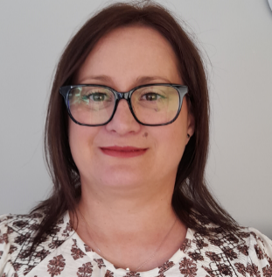Gabi has worked with severe learning disabilities and has worked with adults.

Training: Paediatric First Aid, Medication Advanced Childrens Homes, Positive Behavioural Management, Food Safety & Hygiene Advanced, GDPR, Health and safety advanced, Safeguarding children level 2 children's homes, Covid 19 - Where Are We Now?, Fire Safety

Richard Doonan: Holiday Cover Residential Child Care Officer

Previous Roles /Experience:

Richard has many years’ experience of being a support worker for adults with autism and children and young people.

Qualifications / Training: Degree in journalism, level 2 diploma in health and social care, TCI, ASD, CSE Advanced, Criminal Exploitation and County Lines, Depression and Suicide, Drug and Alcohol awareness, Trauma, Equality, Diversity and Cultural Competence, Fire Safety, Food Safety, GDPR, Health and Safety Advanced, Infection Control, Medication Advanced, Paediatric First Aid, Radicalisation and Extremism advanced, Safeguarding Children Advanced, Working with Disabled Children, Personal Care, Moving  Assisting and Hoist Training, Professional Boundaries, Child Abuse and Neglect,  Risk Management and Safer Caring, Recording and Reporting, PBM training, Sensory Integration, Quality Standards, C Card trained.

Jaycee Latue – Bank Residential Child Care worker

Previous Roles/Experience: Outreach work for roc family support and class room experience

Qualifications/training:

Level 3 diploma Health and social care, Level 3 Psychology  Bullying- how parents can help, Child abuse and neglect, Child sexual exploitation, Children and domestic abuse advanced, contact and birth families, CSE advanced, Depression and suicide, Epilepsy and Seizure management, Equality and diversity, Female Genital mutilation, Fire Marshall training, Fire Safety Children’s homes, Fire solutions, Personal Care, Professional Boundaries in social work, Radicalisation and extremism, Reporting and recording, Safeguarding Childrens advanced, Substance misuse risks children’s homes, working with disabled children, Managing challenging behaviour, Moving and handling, mental health childrens homes, Foetal alcohol children’s homes, food and hygiene, GDPR, health and nutrition Health and safety advanced, infection control.

Sarah Cox – Bank Residential Childcare Worker

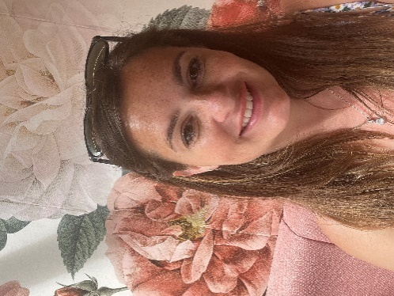Previous roles/Experience; Works across ROC Group and studying ot be a social worker

Qualifications/Training: NVQ level 3 business administration, Health & safety, Peadiatric first aid, Positive behaviour management, Medication advanced, Fire safety, Food safety, Anti-bullying, CSE, Infection control, Risk management and safer caring, Reporting & recording, Radicalisation and extremism, FGM, Equality & diversity, GDPR, Internet safety, Buccal Midazolam and epilepsy

Daniel Lenham – Bank Residential Childcare Worker

Previous roles/Experience; Daniel’s previous career was in the military for 12 years (RAF), before transitioning into working in Health and Social Care in 2015. Daniel has experience working with children, young people and adults in a range of Social, Emotional and Mental Health settings including residential homes, Semi-Independent supported living and mental health provisions.

Qualifications/Training: CV19, where are we now?, Fire Safety 2023, Food Safety & Hygiene Foundation, GDPR 2023, Health & Saftey Advanced, Induction Training, Level 3 CYP, Medication Advanced

Emma Richmond- Bank Residential Child Care worker

Previous roles/ experience: Emma has many years experience working with adults with mental health and learning disability in independent living settings in the Durham Area. Emma was inspired within the role and person experiences to work within the social care and signed up for a social work degree in 2021 and is due to complete in 2024.

Qualifications: Level 5 qualified & Level 3 health and social care extended diploma.

Lee Ann Hill - Bank Residential Child Care worker

Previous experience: Lee Ann wanted to start working with children in 2014 and trained to be a teaching assistant in a local primary school. Lee Ann then wanted a new challenge and obtained a job in an EBD school where she continued her studies to become a teacher. Lee Ann changed roles a year ago once becoming qualified PSHE teacher as well as working in the school, Lee Ann also picked up shifts within the attached children’s homes as a residential child care worker.

Qualifications: Level 2 & 3 in supporting teaching and learning enhanced SEN, foundation degree in care and education, degree in education training, post graduate certificate in Education as well as ADHD practitioner.

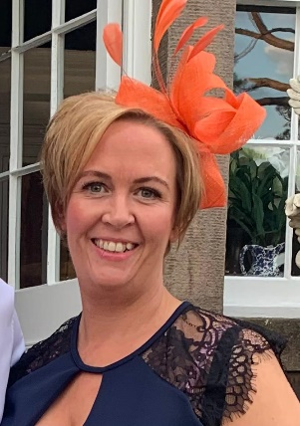Michaela Stephenson - Bank Residential Child Care worker

Previous experience: Michaela has worked in adult care settings caring for vulnerable adults, and she also works in schools teaching young people with Special education needs. Michaela loves to work with and teach young people and finds this is her passion.

Qualifications: Level 3 in health & social care. Covid 19, Fire safety, food hygiene, GDPR, Health and safety, medication advanced, safeguarding children & young people, diabetes basic & advanced.

Helen Naylor – Bank residential childcare worker

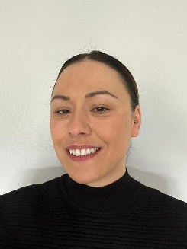Previous roles/Experience; Helen works part time within The Hawthorns.

Qualifications & Training; Introduction to level 1 councelling, Level 2 introduction to Neuroscience in early years level 2 understanding children & YP mental health.

Diabetes basic & advanced, Fire safety childrens homes, Medication advanced, safeguarding, covid 19, attachment & bonding, ASD, food safety, GDPR, health & safety, key working, paediatric first aid, PBM, professional boundaries.

Jolene Ramsay – Bank residential childcare worker

Previous roles/Experience; Has worked for ROC for 9 years supporting children and young people with additional needs to learn life skills and take part in activities. She is also a teaching assisstant within a SEN school.

Qualifications/ training: Highest qualification is BA (hons) degree in early childhood studies. Level 2 childcare & education, Level 3 education & childcare, Level 2 Health & social care.

Autism, Bullying, Child abuse & neglect, Child development, CSE advanced, Contact & birth families, Covid 19, Depression & suicide, Drugs & alcohol, Epilepsy & seizure management, Epistatus, Equality & diversity, FGM, Fire safety children’s homes, Food safety & hygiene advanced, GDPR, H&S advanced, H&S and fire & coshh, Infection control, Safeguarding children advanced children’s homes, Lone working, managing challenging behaviour, medication advanced, Mental capacity children’s homes,

mental health in young people, Moving & handling, Moving assisting and hoisting, nutrition & wellbeing, Paediatric first aid, personal care & diversity, PBM,

professional boundaries, radicalisation & extremism, reporting & recording, restorative practice, risk management & safer caring, Safe Practices in Medication, sexual abuse in schools and colleges children’ s homes, substance misuse, working with disabled children.

**Team Structure**



Audits

Weekly and monthly audits will be carried out by team members in the following areas:

* Health and safety
* Fire Checks
* First Aid Equipment checks
* Building Audit
* Car checks including insurance, MOT, Fire Extinguisher & First aid kit

The management will audit all paperwork and young people’s files on a weekly basis.

Once a month, an Independent Visitor from NYAS conducts a full regulation 44 audit of the home to ensure all standards are met. An action plan will be given to the manager to complete by next visit. Every six months the Registered Manager and Responsible Individual will meet with the NYAS visitor, review previous six months and compile report Regulation 45 to send to Ofsted. The Registered Manager will complete monthly Reg 45 reports which will be analysed in monthly Service Performance Meetings with the Responsible Individual.

OFSTED will conduct unannounced inspections and will grade the home appropriately.

Fire checks will be carried out yearly by the local fire brigade and PAT Tests CP12, Health and Safety and NICEIC Electrical tests will also be completed by an independent company.

The company also has extensive liability insurance and there are contingency plans in place in case of incidents and emergencies.

The Executive Leadership Team meet on a monthly basis and have a responsibility for:

* Strategic Vision, Direction and Forecasting of the Organisation
* Culture, Values and Principles
* Quality Assurance
* Policies and Procedures
* Annual Business Plan
* Training and Development Issues
* Financial Management and Expenditure
* Legal / Health and Safety Compliance of the Organisation

ROC Group’s Board, meet quarterly and have a responsibility for:

* Strategic decision making
* Financial viability
* Strategic reporting

The big

picture

Huthorn is geared up to prepare young people for their life ahead and equip them with the skills they need to thrive.

Whilst we want every young person to feel at home at Hunthorn, we know that the day will come when each resident will be ready to move on into independence. We aim to have given them the support they need to be able to accomplish their dreams, whilst being able to manage things such as securing their own tenancy, budgeting, cooking and being able to care for themselves outside of our home.

We have developed a ‘Staying Close to Home Model’, where If the young person would like to stay within the ROC Group family then they can move on into our supported acoomodation provisions. This could either be our supported housing charity, ROC Solid, or if a greater package of support is needed and they are between 16 and 18 then they can move into our Transitions service. If you would like to know more please contact 01325 310009 or visit www.rocgroup.org.uk

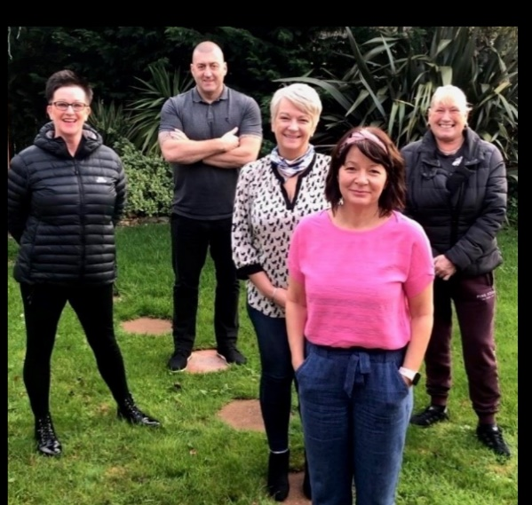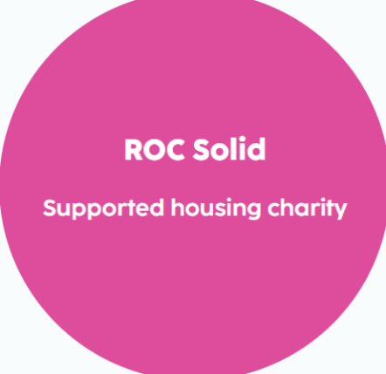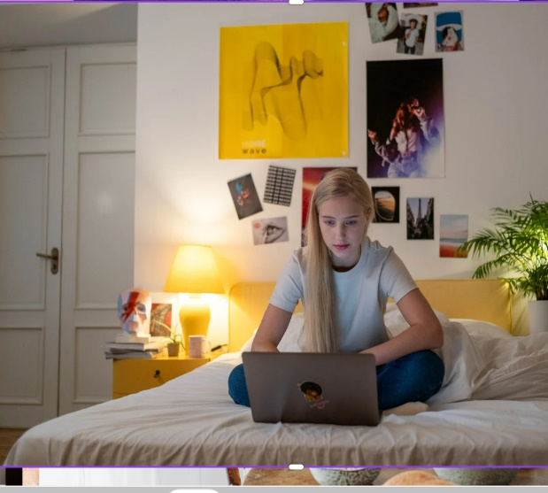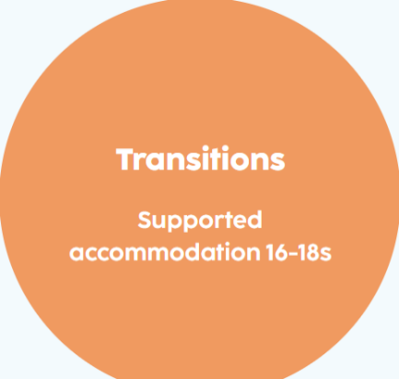

Compliments

& complaints

At Hunthorn we actively seek the views of young people, and their families, to help us to improve our services. We treat complaints, comments and compliments seriously. Information regarding how to make a complaint is recorded in the Young People’s Guide which is received on admission. Complaints in the first instance can be made to the Registered Manager by contacting them via email at [Daniel.White@rocgroup.org.uk](mailto:Daniel.White@rocgroup.org.uk) or telephone 01325 310009.

Young people are made aware of the function of independent advocates, NYAS. Every young person is given contact information for this organisation.

We usually try to settle any issues locally, using restorative approaches; this is generally the most effective way of resolving any problems between people. We aim to do this in an inclusive way with the young person, their family and social worker, if appropriate.

There are times, however, when it is helpful for someone outside of the home to have a more independent view. If this is the case a more formal process may be followed, using the framework set out in Hunthorns Complaints Procedure. Where a complaint cannot be resolved internally, an independent Investigating Officer from a company such as ‘The Children’s Society’ will be appointed to look into the issue.

Complaints and representations will be recorded in Charms, along with actions taken, the outcome and the lessons learnt. Our complaints are monitored by the Responsible Individual.

Copies of our complaints, procedure can be obtained from:

ROC Group Ltd

Hope House

Burnhope

Newton Aycliffe

County Durham

DL5 7ER

 Telephone number: 01325 310009

Email: [info@rocgroup.org.uk](mailto:info@rocgroup.org.uk)

Complaint

contacts

**INVESTING IN CHILDREN:** Tel: 0191 3729200

Email: iiccic@outlook.com

**NYAS:** FREEPHONE 0808 8081001  
Email: [help@nyas.net](mailto:help@nyas.net)

**THE CHILDREN’S RIGHTS COMMISSIONER:**

The Office of the Children’s Commissioner

Sanctuary Buildings

20 Great Smith Street

London

SW1P 3BT

Freephone: 0800 528 0731

Tel: 020 7783 8330

Email: [info.request@childrenscommissioner.gsi.gov.uk](mailto:info.request@childrenscommissioner.gsi.gov.uk)

**OFSTED:** Young people, Parents, Social Workers or team members can also complain directly to

Ofsted

Piccadilly Gate

Store Street

Manchester

M1 2WD

Tel: 0300 123 1231

If you would like to see a copy of our policies and procedures, please contact Lynn Cunningham on 01325 310009 or info@rocgroup.org.uk.

