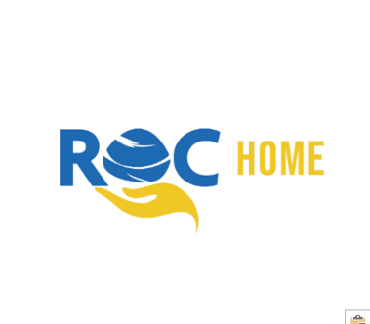

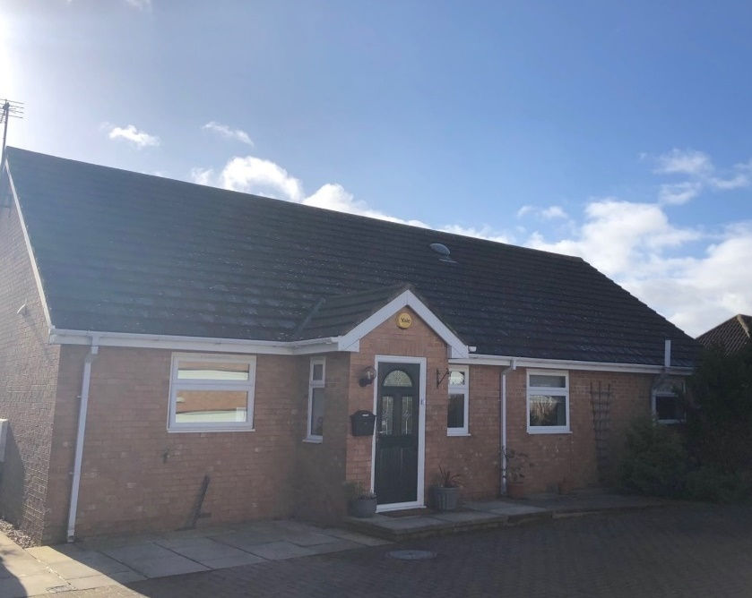



**Statement of**

**Purpose**



The Hawthorns

Version 31

Date of Original Document: 2nd August 2019

Date of Issue: 07/03/2024

**Registered Manager\***

**Kaylie Mullin**

*Currently on Maternity Leave*

**Contact:** [**Kaylie.Mullin@rocgroup.org.uk**](mailto:Kaylie.Mullin@rocgroup.org.uk)

**TEL: 01325 327144**

**Interim Manager**

**Alexandra White**

**Contact:** [**Alex.White@rocgroup.org.uk**](mailto:Alex.White@rocgroup.org.uk)

**TEL: 01325 327144**

**Responsible Individual**

**Laura Roberts**

**Contact:** [**Laura.Roberts@rocgroup.org.uk**](mailto:Laura.Roberts@rocgroup.org.uk)

**TEL: 07957552518**

**Registered Provider:**

**ROC Family Support Ltd**

**Hope House**

**Newton Aycliffe**

**Co Durham**

**DL5 7ER**

**Tel: 01325 310009**

**Email:** [**info@rocgroup.org.uk**](mailto:info@rocgroup.org.uk)

**Web: www.rocgroup.org.uk**

**Ofsted Registration Number: SC 2571902**

**\*The Registered Manager must ensure a copy of The Statement of Purpose is on display in the home and that a copy is given to all residents, parents, staff and social workers involved at The Hawthorns.**

Contents

Who We Are 4

Core Values 5

Our Objectives 6

The Hawthorns 7

Placement Types & Admission Criteria 8

Admissions 9

Emergency Admissions 10

About the House 11

Newton Aycliffe Area 12

Equality, Diversity & Identity 13

Family & Friends 14

Having A Say 15

Safeguarding 16-17

Emergency Safety 18

Security 19

Unauthorised Absence 20

Managing Behaviour 21

Physical Intervention 22

Education 23

Having Fun 24

Health & Wellbeing 25-26

Team members Rota 27

Meet the Team 28-35

Audits 36

Big Picture 37

Compliments & Complaints 38

Complaints Contacts 39



Who we are

We started in 1999 with the aim of helping people however we could. We meet the needs of people in the northeast by providing outreach support, supported accommodation, supervised and supported family time and homes for children.

We are passionate about making a difference to the lives of the people we work with and our teams go over and above to make sure this happens. What makes us special? **Our People.** The culture they have created is award winning! Some of our ROC Group accolades include;

* National Care Employer of the Year 2022 (Children & Young People’s Awards)
* National Housing with Care Winner 2022 (GBCA)
* Investors in Children Gold
* CQC Outstanding at 4 Consecutive Inspections
* Ofsted “Good” Provider
* Enhanced National Association of Child Contact Centre’s Accreditation
* IASME Governance certified

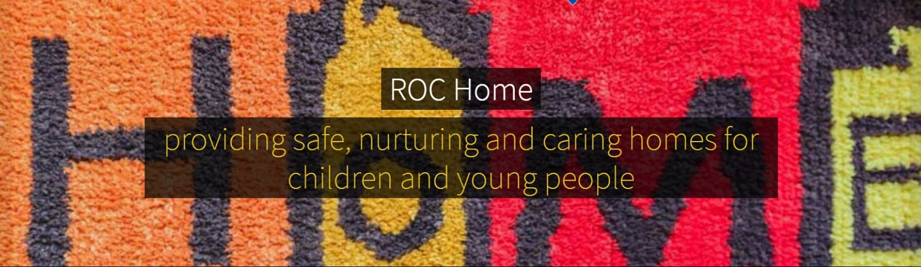

*ROC Home Mission Statement 2019*



Core values

As a team we have eight core values, which are very important to us. They run like golden threads through everything we do and how we treat people. They are:



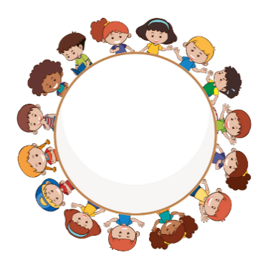



**Equality and diversity**

**Recognition**

**Learning and personal development**

**Safeguarding**

**Listening and consultation**

**Working together**

**The rights of children and young people**

**Integrity, transparency and respect**

Our aims

* To provide a high-quality, residential service which has focus on continuous improvement and quality assurance
* That all homes will offer stability, security and a warm, safe caring environment in which children can positively thrive
* That children and young people are provided with structure and consistency of boundaries
* To encourage expression of views and listen to them, acting on them where possible
* To help children and young people to achieve the 5 outcomes from Every Child Matters:

1. Be healthy
2. Stay Safe
3. Enjoy & Achieve
4. Make a Positive Contribution
5. Achieve Economic Well-Being

* To ensure that the children and young people in our care receive educational support
* To provide therapeutic-based support to children and young people
* To provide consistent and reliable Team members who can be “role models”
* To be a positive influence on behaviour, tailoring our behavioural approach to the needs of the person
* To support young people to change behaviours which could impact upon their quality of life
* That children and young people work together to make decisions for the home
* To establish strong links with the local community and build good relationships
* Ensure the cultural and diversity needs of each child are met
* Encourage children and young people to get involved in social and leisure activities and enable them to make positive use out of their free time
* To enable young people to transition to leaving care by supporting them with a range of life skills training
* To promote good communication and effective working relationships with children and young people, our teams and all stakeholders
* Provide Team members who have the necessary knowledge, skills and experience required to provide a service delivered to national standards
* Promote family time and positive friendships
* Provide 24-hour telephone support, via an on-call service



The

Hawthorns

* The Hawthorns is a specialist home which provides support for up to three young people, of any gender (dependent on matching) from ages 8-17, who have emotional and behavioural difficulties. Young people will usually stay for several months up to a number of years depending on their individual plan.
* The Hawthorns is staffed by appropriately qualified, inducted and trained Team members. Young people are supported on a 3:3 or 2:3 basis by Team members working on a rota pattern. Waking nights are not required, although can be put in place as needed.
* Children and young people are encouraged to develop safe, stable and secure relationships with adults in the home. As such, we allocate a keyworker to each young person to offer individual support. These workers take an important place as a core member of the team around the child, contributing to planning and decision making.
* The practices at The Hawthorns are inclusive and support young people to develop in terms of life-skills and emotional and mental resilience, to a point where they can cope without our support, return home, to another placement or to live independently.
* We believe in equal opportunities for all. Young people will not be discriminated against on the basis of age**,** race**,** religion, pregnancy, gender reassignment, sex, sexual orientation or disability. All Team members receive training in equal opportunities and diversity.
* Young people are sensitively supported in exploring their identity, in relation to any and all strands of diversity as appropriate. We actively assist young people where they follow any particular religion, and will forge links with local providers to ensure that any cultural needs in terms of diet, clothing etc are met.
* The Hawthorns receive regular consultation from ASPIRE psychological services. Aspire provide advice and support for the team and children and young people. This can range from developing a knowledge base, skills, expertise in understanding complex presentations, reflective practice on behaviours that may challenge.
* The home uses the principles of PACE and positive behaviour support to provide a nurturing environment with a focus on long term outcomes.





Placements

**Placement Types:**

* Solo Placements
* Dual Placements
* Triple Placements

**Admission Criteria:**

The Hawthorns is open to up to three young people of any gender aged 8 to 17 years predominantly exhibiting

* Emotional and Behavioural or Educational difficulties







Admissions

We aim to make the young people who come to live at The Hawthorns feel ***at*** home.

To help do this, we have an admission meeting which will include the young person and their family, the social worker and representatives from the home (usually the manager and a keyworker).

Information will be shared between all parties, to enable us to care for the young person effectively, and the placement agreement and safety plan will be made and signed.

The child or young person will be shown around the home and introduced to other residents and the team. They will be given a welcome pack, which includes some goodies, and a guide containing information such as fire procedures and how to make a complaint. A keyworker will spend time with them, to help them settle in, and pick which paint colour they would like for their room! On some occasions, there will be several visits, and overnight stays, to prepare the young person for their move.

Young people already in the home will be prepared for a new admission by 1:1 keyworker sessions or sometimes young people’s meetings. Appropriate information will be shared with them, to help to minimise the impact of change on them.



Emergency admissions

Admissions will usually be on a planned basis, to make sure the individual needs of all the children and young people in the group are met. The admission process is governed by the needs of the young person, for example sometimes a quicker move may be needed.

On rare occasions admissions may be made in an emergency, where this is in the best interest of the child.

The following criteria must be met:

* The placement is part of a care planning process which addresses the needs of the young person
* The placement will provide the best available method of achieving the aims and objectives of the plan for the young person and will meet the young person’s assessed needs
* The placement is in accordance with the home’s Statement of Purpose
* The home is able to provide levels of care appropriate to the needs of the young person
* The young person’s needs will be assessed in conjunction with the needs of the young person already resident at The Hawthorns, and there are no grounds for considering that this placement will significantly impact on any current young person or the young person themselves
* A care planning meeting must take place within 48 hours of the placement

The decision regarding the placement will be based on all of the above, after considering the available documentation, e.g. care plan, assessments, risk assessments, talking with the child/ young person, parents, the social worker and other agencies, if applicable.



About

the house

The home is a 5-bedroom dormer detached bungalow, converted to meet the requirements set out by the Children’s Homes Regulations 2015.

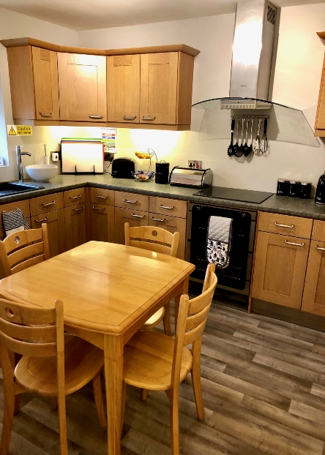Each young person has his/her own bedroom which contains a television. Young people are given a key for their room and there is also lockable storage in the room to keep personal and private things safe. There is also a lounge/diner, conservatory, a den upstairs, breakfasting kitchen, a utility room, office with sleep in facilities for Team members, an office for the homes manager, 3 bedrooms for young people, 1 Team members sleep in room, bathroom, a shower room,1 en-suite for Team members, 3 toilets in total, garage and a spacious paved and garden area outside.

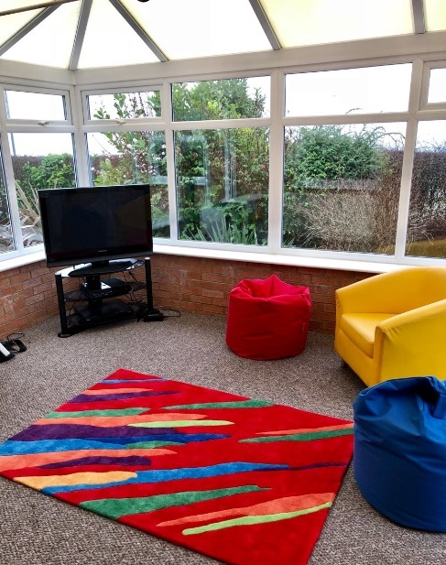

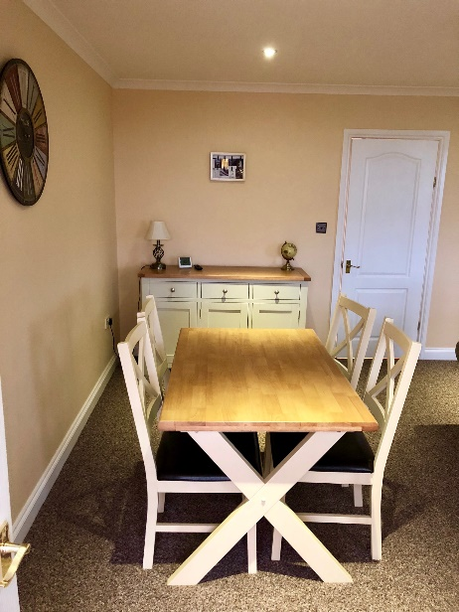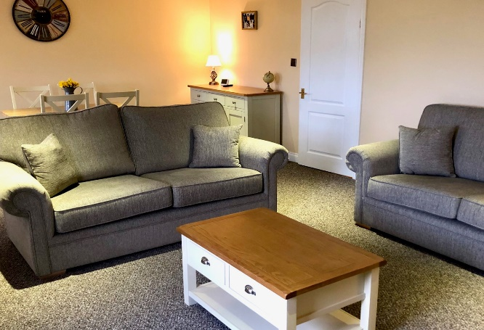



The local

area

We are situated in Newton Aycliffe, within walking distance to a local shop, playing field, sports courts and play areas.

The bus stop is accessible by going through an underpass with bus routes into Darlington, Durham and surrounding towns.

Young people can access cinemas, theatres, play areas, climbing walls, leisure centres, gyms, sports clubs and shops by public transport. Other attractions include Hamsterley Forest, Hardwick Park, Auckland Castle, various horse-riding centres, Beamish Museum and Lightwater Valley theme park.

There are local primary schools and secondary schools within walking distance from the home.

At The Hawthorns, we are building relationships with the local community. The senior team are committed to getting involved with the community for example by attending PACT meetings and getting involved with local charities.

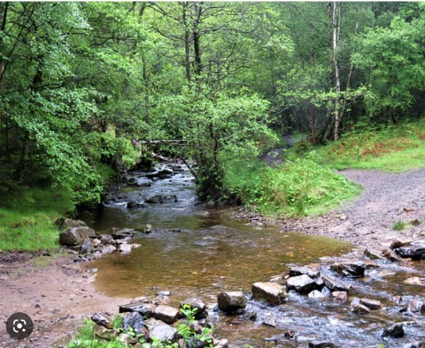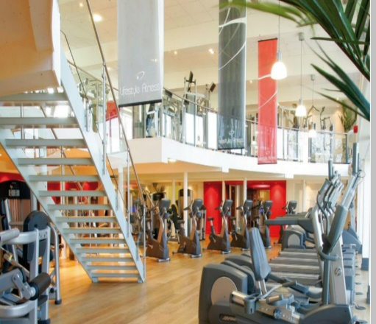

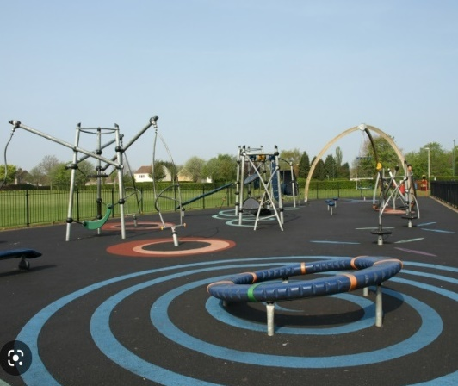



Equality

&

diversity

The Hawthorns provides a learning, working and social environment where the rights and dignity of all are respected, which is free from discrimination, prejudice, intimidation and all forms of harassment and bullying.

We are proud to be diverse and inclusive, where individual differences are accepted and valued, and where everyone is able to fulfil their potential. The home is opposed to all forms of discriminatory behaviour.

We believe that all young people, visitors and Team members are entitled to respect and to live and work in a welcoming, safe and non-threatening environment.

Any complaints of discrimination or harassment will be treated seriously, be fully investigated and any appropriate action taken by management.

We are strong advocates of children’s rights, and where a young person’s views are not being heard, we will offer the support of an independent advocate to support them.

As part of the admissions process, we will make enquiries about a young person’s religious beliefs (if any) and discuss with them and their parents/carers the arrangements which need to be made to enable the young person to follow their religion e.g. adjustments to menus, facilitating attendance at religious festivities etc. We will also ensure that the necessary arrangements are in place to meet a young person’s cultural needs such as traditions.



Family

& Friends

The team at The Hawthorns help to maintain and support relationships between young people and their families and friends in as positive a way as possible. We recognise how important this can be in their overall progress and development. Family time arrangements will always be discussed as part of the admission process and can be facilitated by our team. This will include who can give permission for overnight stays with friends and family which then forms part of the Placement Plan. Any known restrictions will be made clear and will also be included in the Placement Plan. These will be fully explained to the child/young person.

Children and young people will be provided with practical support for family time with parents, families, and other significant people. This may include transport, telephone calls, e-mails etc where it follows their plan of care and is safe to do so.

We will provide families with regular feedback, in a format agreed with them, regarding the child/young person’s progress. We aim to include them in as many decisions as possible where it is appropriate.

We try to ensure that young people maintain healthy relationships. Time with established friends will be promoted wherever possible, encouraging friends to visit the home where this is appropriate. We will support them in making new friendships, where appropriate. Plans will take into consideration the age and vulnerability of the child/young person and identify where some supervision is necessary to keep them safe, for instance regarding access to social networking sites.

Parents and other relatives will be made welcome. Family members will be offered refreshments. Records will be kept in the visitor’s book and in the child/young person’s file recording the date, time and length of visit. A child or young person will be allowed the right to refuse to see a relative, if they so wish. In the event of this occurring with a child under the age of 16 years, where mediation is unsuccessful, further advice will be sought.

The team will adopt a restorative approach if there are difficulties between young people and their family or friends, to try to resolve the situation.

Wherever possible, any decisions about children/young people will be made in consultation with their parent/family.

Any serious incident, e.g. accident, illness, injury, or if the child/young person is missing, will be communicated, wherever possible, with parent(s) immediately or in accordance with pre-agreed plans.

Having

a say

We know that nothing is more effective than forming positive, open relationships with children, young people and their families where individuals feel empowered to put forward their honest opinions.

We want children and young people to be involved in running the home. We care about their and their parent’s views on issues to do with the running of the home.

Monthly, recorded house-meetings are held, where children and young people can set their own agenda, and help with decision making about aspects of the home, for instance; holidays, decoration, activities etc. Key working sessions can serve the same purpose for those who find it easier to pass on their thoughts one-to-one or struggle to express their feelings in a group.

Their views are recorded in Charms (online system), for example, regarding bullying, any restraint, consequences of actions etc. The Registered Manager will use this information as part of their monitoring of the home under Regulation 45 of the Children’s Homes Regulations 2015.

Views are regularly sought from parents and social workers about the care that young people receive at the Hawthorns. As well as obtaining this verbally, we also send out quarterly feedback forms to families and professionals involved in the child/young person’s life. We try to use this to improve what we do. We are proud to have been awarded Investors in Children Gold status, which demonstrates our commitment to listening to feedback and acting on it.

As part of Regulation 44 of the Children’s Homes Regulations 2015, an independent visitor from National Youth Advocacy Service (NYAS), comes to the home and provides a report of their findings which is then shared with the management of the home and Ofsted. One of their tasks is to spend time talking to children/young people to form an opinion about the quality of care we provide. Ofsted also seek the views of children/young people, families and social workers as part of their inspection process.





Safeguarding

The Hawthorns is subject to the Durham Safeguarding Procedures. All Team members undertake safeguarding training and are made familiar with these procedures. Safeguarding refresher training is available via e-learning courses.

We use safer recruitment processes in line with Durham Safeguarding Children Partnership, (DSCP), and practice safe care procedures. We also have lone working policies and procedures to safeguard everyone involved.

We have created an open culture, where Team members and young people are able to discuss any concerns of a child protection nature, without fear of consequences. We encourage speaking out about concerns around practice, where it is felt that it cannot be dealt with through normal routes, or they are of sufficient seriousness, to warrant bringing to the attention of the Responsible Individual or Directors.

Team members can often be the first to realise that there may be something wrong within the organisation, but they may not feel comfortable expressing their concerns, as they might feel that “speaking out” would be disloyal to colleagues, managers or the organisation.

In instances of allegations against Team members, we will ensure that the Local Authority Designated Officer has been informed.

Team members will be trained to know how to report immediately any abuse, or suspicions of abuse whether this has taken place inside or outside of the home. This is covered within our Whistleblowing and Safeguarding policies.

Children and young people are advised on what to do if they are being hurt or abused in any way. They are provided with our Guide which has numbers for NYAS, Ofsted, and Child-line etc. They will have access to a telephone which they can use without supervision, unless it is not appropriate.

As part of key working sessions, we will discuss with young people their rights and how to pass on compliments and complaints.

The Hawthorns has a policy on countering bullying which is reviewed annually. These policies include identifying bullying, addressing bulling and how to support victims and perpetrators of bullying. Key workers talk to young people about bullying and how to stay safe.

All child protection incidents are recorded according to Durham Safeguarding Children Partnership procedures, and cross referenced within the homes’ electronic database (Charms).

We make it our business to understand what is happening in the local community, working closely with neighbourhood police, to pool information in order to keep young people safe. We record any known risks in a locality risk assessment and review this as required, to keep the information current.

The Registered Manager is the lead person in the home to take responsibility for overall safeguarding issues.

Our full child protection policy can be obtained by contacting Lynn Cunningham on 01325 310009 or Info@rocgroup.org.uk.



**Safeguarding contact numbers:**

| **Name of**  **Local Authority / Gov Agency** | **NAME** | **website/ADDRESS** | **EMAIL** | **TELEPHONE** |
| --- | --- | --- | --- | --- |
| **Durham** | **First Contact Service** | <https://www.durham-scp.org.uk/> | [scd@durham.gov.uk](mailto:scd@durham.gov.uk) or  [firstcontact-gcsx@durham.gcsx.gov.uk](mailto:firstcontact-gcsx@durham.gcsx.gov.uk) | 03000 26 79 79; Fax: 0191 383 5752; Minicom:0142 988 4124  Emergency Duty Team  03000 267 979  Text:  0778 602 7280. |
| **Safeguarding Adults** | http://www.safeguardingdurhamadults.info/ |  | Call: 03000 267 979 |
| LADO | County Hall Durham | [lado-gcsx@durham.gcsx](mailto:Yvonne.davies@durham.gov.uk) | 03000 268 835 |
| **Ofsted** |  | Ofsted Piccadilly Gate Store Street Manchester M1 2WD | whistle.blowing@ofsted.gov.uk  enquiries@ofsted.gov.uk | 0300 123 3155 |
| **Police** |  |  |  | 101 non emergency  999 emergency |

Emergency

safety

* All Team members receive training and guidance around health and safety, which includes fire safety. This is regularly reviewed and updated. The Registered Manager audits and monitors health and safety within the home.
* We comply with guidance provided by the Health and Safety Executive, (HSE), and local fire authority, to keep children, Team members and visitors safe. All young people are given information about what to do in the event of a fire, when they first visit the home.
* Risk assessments are carried out and recorded in writing on our data base. The Registered Manager will regularly review the implementation and effectiveness of actions identified.
* The Registered Manager ensures that The Hawthorns fire procedures are adhered to. This includes ensuring that regular fire drills are carried out, including in the hours of darkness, and all children and Team members know the emergency evacuation procedures for the home, in the event of a fire.
* The Manager and Team members will make sure that The Hawthorns, its premises, equipment, furnishings and fittings are physically safe and secure and that any defect is promptly remedied.
* The local environmental Health Service assess the food storage and preparation provision of the home and will be consulted as required if any concerns are raised.
* ROC Home has an Emergency Contingency Plan which will be implemented if required for any major crisis. The on-call rota operates 24/7. The duty worker will work with Team members on duty in the home to seek the best resolution for residents, should a serious situation arise. This could include transfer to alternative ROC properties, or hotel accommodation





Security

Our home has in place security systems which ensure that the home, the people who live there, and its contents are kept safe. This includes locking certain doors, throughout the day/evening/night, in such a way that does not prohibit Team members or young people from leaving the premises, but denies access from outside. On some occasions, internal doors may be locked for specific health and safety reasons or for issues of confidentiality.

There is an alarm system fitted which may be activated at certain zones to screen any unwanted access or movement around the home. This includes door and window alarms which sound when opened and a burglar alarm. This is solely intended to protect the interests of the people within the home. It is not intended as a tool for monitoring the movement of individuals, but is intended to maintain the safety of young people.

Children and young people also have a lockable safe for their valuables and bedroom door keys.

This list does not include any system of tagging etc imposed by a court or prison authority as part of Youth Justice Board actions.



Unauthorised

absence

Sometimes staying out late happens because children and young people may be having fun with their friends, but sometimes this isn’t a safe thing to do. Children and young people who are absent from our home, without consent, are protected in line with The Police and Durham County Council’s joint written policy and guidance on Children who go Missing from Home or Care. This policy is consistent with national legislation.

To help prevent non-agreed absence, and to protect them if they do not return, we:

* Go out and look for them, if we have any idea where they may be
* Contact friends and family to find out if they know their whereabouts
* Work hard to build positive relationships with children and young people and engage them in pro-social activities, within the community to promote confidence, self-esteem and a sense that this is their home
* Support their friend, family and social networks, unless we have grounds to believe this is not in their best interest
* Provide guidance about relationships appropriate to their age and understanding
* Ensure that where a child/young person has a history of going missing, this will be reflected in the safety plan, along with how we aim to keep them safe, whether they are missing or absent from their designated proper place.
* Share all information with the police and Emergency Duty Team (EDT), in a timely way to ensure that there is a multi-agency response to the individual needs of the child/young person who is missing, particularly if risks are high
* Arrange an independent Return from Missing interview
* Document, report and record incidents of absence from the home, and discuss in Service Performance Meetings and quarterly Board meetings to establish trends and design mechanisms to prevent further absences

Where a specific risk is identified, or the child has been missing several times, we take part in multi-agency meetings with the police, and members of the care team, to make sure our safety plan is robust and we are working together to minimise risk.



Behaviour

We use Positive Behaviour Support to improve the quality of life of our children and young people, increase their positive behavioural repertoire and teach new skills. We use functional assessments where necessary to determine the reason behind the behaviour and develop strategies which motivate the child/young person to change their approach to having their needs met.

* We respond positively to positive behaviour
* We share and acknowledge good behaviour
* We work on rewards, rather than punishment
* We use our positive relationships with young people to deal with issues in a restorative way

**Learning Lessons**

There are some sanctions which are not allowed under The Children’s Home Regulations 2015, for example withholding food or drink or medicine. To see a full list of prohibited sanctions, visit <http://www.legislation.gov.uk/uksi/2015/541/regulation/19/made>

* If a sanction is necessary, we try to negotiate something suitable within a range of acceptable disciplinary measures.
* Sanctions could include the repair of an item broken or financial contribution to the item being fixed. Sanctions should where possible be related to the incident so that the child/young person can make the connection with the consequence.
* Young people’s views of any consequence of action are recorded in our database (Charms) for this purpose, and its effectiveness is monitored.
* Our home has a policy on behaviour management including an additional policy on the use of restraint and restraint reduction.

Our full behaviour management policy can be obtained by contacting Lynn Cunningham on 01325 310009 or [Info@rocgroup.org.uk](mailto:Lynn.Cunningham@rocgroup.org.uk).



Restrictive

intervention

A focus of our Team members development programme is to help them understand how best to work with those who display a range of complex behaviours. Positive Behaviour Support focuses on using restrictive interventions as a last resort to keep people safe and use strategies only where there is the data to support their use. In addition, we receive support where required from Child and Adolescent Mental Health Services, (CAMHS) and Local Authority social workers. This reduces the need to use physical intervention in the home. As a safeguarding measure, however, all Team members are trained and refreshed regularly in Positive Behaviour Management, which includes techniques in deflection, distraction and de-escalation, breakaway’s and low-level restraints where there is a need. Their competence is assessed by the trainer and any issues fed back directly to the Registered Manager who will make a decision about their fitness to be involved in restrictive interventions. Each child/young person has a Positive Behaviour Support Plan which details the function of behaviour and strategies at each level of the Time Intensity Model. As a general rule, restrictive intervention will only be performed to keep people safe or where there may be significant damage to property.

Where restrictive interventions are used, this is recorded on an electronic data base, and young people are asked to include their views about the event. They will be given the opportunity, via a life space interview, to discuss the incident and agree ways in which situations could be better handled, if they were to arise again. Their social worker, family and Ofsted will be informed. Documentation will include who performed the restrictive intervention, which technique was used, how long it lasted and whether any injuries were sustained and/or medical intervention was required.

The use of physical intervention, and documentation, is closely monitored within the home by the Registered Manager and ROC Group’s Positive Behaviour Support team. Where it is has been necessary to use physical intervention more frequently to keep young people or Team members safe, advice will be sought from outside agencies, such as CAMHS, to ensure that we are working in the best interest of that child/young person.

If you would like to see a copy of our behaviour management policy/restraint reduction policy please contact by contacting Lynn Cunningham on 01325 310009 or Info@rocgroup.org.uk.





Education

We are committed to improving the life-chances of every person who lives with us. Education is a very important part of this outlook. Education will be given a high priority at planning meetings. A multi-agency decision will be made about the viability of maintaining the young person’s current school placement, as part of the admissions process, which will include the young person’s and families’ views.

We work closely with Looked after Children’s Educational Services, (SEND), who allocate a keyworker to all our young people of statutory school age. They help us to monitor attendance, educational progress, and are part of our team around the child.

Keyworkers work closely with the Designated Teacher and Form Teacher within the young person’s educational provision. We aim to ensure that there are excellent channels of communication, so that the young person can see that we are working together to help them achieve their full potential.

We will share information with them to identify barriers to learning. Keyworkers will attend certification days, open days, sports days, etc, and will ensure that educational achievements are suitably celebrated. The Team members strive to ensure that all young people are supported to continue their learning outside of their education placement. We actively seek educational experiences for young people to enhance learning.

For young people outside of statutory education, keyworkers ensure that appropriate services are accessed to assist them in finding and sustaining suitable training or employment opportunities.

The Hawthorn’s adopts a culture whereby attendance at school, training or work is the norm. This is supported in the education policy. The team support education by providing materials, supporting young people with homework and helping them to prepare for their studies the following day.

Promotion of education, specific school subjects and work placements will not be limited by assumptions about traditional gender roles.





Having

fun

Every child and young person have the right to have fun!

We understand how exposing young people to a range of leisure experiences and activities can improve self-esteem and support learning and development. With this in mind, young people are encouraged to participate in hobbies, clubs and activities. Our aim is to help young people access activities within the community which they can continue into adulthood.

Keyworkers will find out from young people what leisure pursuits they enjoy, and what they are good at, and facilitate the continuation of any hobbies. Young people will be given the opportunity to participate in the activities they wish to pursue, which encourages the development of creative skills e.g. painting, poetry, and music, as well as sporting and physical activities. Team members will participate in these activities, where appropriate, to provide encouragement and support.

The home has a wide range of puzzles, craft equipment and games. We will normally have games consoles and a computer for the young people to use for leisure and home study purposes (which will always get priority over game playing!). It is linked to the internet which can be used with supervision as dictated by a young person’s risk assessment.

The children’s homes Team members will consult with young people about the provision of opportunities, which promote the development of cultural and artistic needs, and plan for such opportunities will be done at both a group level i.e. in young people’s meetings and in key-working sessions and planning meetings.

The issue of parental consent will be considered for activities which are provided outside the children’s home i.e. leisure centre, youth club etc.

Our young people benefit from Durham County Council schemes to encourage children to become involved in sport and leisure activities, meaning that many of these can be accessed free by use of the council’s swipe card process.

We also take the young people at The Hawthorns away on holiday for a maximum of 14 nights throughout the year, normally within the UK.

Monthly “ROC Stars” events are in place which are directed by the young people and include trips, activities and events.  The agenda and planning are led by the young people who attend.  This group provides a forum for listening to the young people and their ‘voice’ is used to shape the service delivery of ROC Group.

Health &

wellbeing



Our team are focused on helping the young people in our care be healthy and happy. At The Hawthorns, we have a health champion who promotes healthy objectives and supports our young people to take care of their health. This could include going shopping together for healthy food and then making recipes together, gaining access to local gyms or motivating the young person towards a health goal.

Public Health England reports that 60% of Looked After Children have some form of emotional or mental illness. We work to provide stability for young people, so that they can be supported to navigate these issues. We undertake direct work with the young person, but also provide support and training for our team where a young person’s needs are particularly complex, or where the child is not ready to engage with services. We also utilize provisions such as our local CAMHS team who are at hand to offer help and advice to Team members as well as supporting young people with their mental health needs.

The Team members are trained in substance misuse and have made links with County Durham drug and alcohol services to remain informed on current drug use trends in the region.

Young people, on admission, are always registered as a matter of urgency with a local G.P., a dentist and an optician of the child’s choice if possible. We have designated Team members who take a lead role in health and attend health representatives’ meetings, and filter information throughout the team.

Young people will be encouraged to undertake regular health checks to monitor progress in this area and to help us assess the effectiveness of our approach, along with our health colleagues, including the Looked After Nurse.

Keyworkers will work closely with families and other agencies to ensure that our health information is comprehensive, and health targets will always form part of the Placement Plan for each young person. These targets will be evaluated and reviewed to ensure health plans are making a difference to the young person.

Team members also have links to the local pharmacy who will advise us on safe storage and disposal of medication as well as a range of health issues. Training can be accessed by Team members from the Looked after Nurse and other health professionals. Where a young person has specific health needs, advice and training will be sought from a relevant specialist.

Part of our role is to provide guidance and advice around health issues. We will actively discourage smoking, alcohol and substance misuse and ensure that young people are aware of health risks associated with these actions. We have Team members trained to give age appropriate guidance around sexual health and relationship matters, and will always provide this for young people. We will also give general advice and support around how to maintain a healthy lifestyle, and will encourage young people to eat well and exercise. Where any of these issues are a concern for an individual young person, specific targets will be included as part of the Placement Plan, and help from other agencies may be sought.

Team members will not smoke in the presence of young people or consume alcohol while looking after children and young people.

Where required, specialist advice will be sought to provide for the needs of children and young people from minority ethnic and cultural groups, or where a young person has a particular health issue, disability or condition.

We will always check that health professionals have appropriate qualifications and experience, if they are not employed by the local authority.

All Team members are trained in paediatric first aid. We also have a core of Team members who have undertaken ‘First Aid at Work’ training, or equivalent. A designated first-aider will be identified on each shift.



Team

rotas



Team members work a variety of duties which, full time, equate to 40 hrs per week over each month. The manager works flexibly throughout the week in order to observe practice for all Team members and manage the home during different aspects of day to day life.

The intensity of Team members cover depends upon the number of children residing at the home, at a given time, and the assessed risks for each child. For example, if there are three residents there will be two or three Team members working with them with the additional oversight of the Registered Manager at varying times of the day. Overnight there will be two Team members on duty, this may be one sleeping and one awake, or both sleeping depending on safety plans. There are eight full-time Team members employed to cover the care of the young people, as well as the Registered Manager. If there is a need to increase staffing levels, we have a pool of appropriately recruited, qualified, trained and experienced Team members from our other ROC Group services who are able to accommodate any extra requirement. A rota is available to be viewed to see who is on duty at any time.

A lone working policy is in place in the home. Staffing levels are regularly reviewed as part of the risk assessments of individuals and groups of young people. Rota’s may be altered to suit the varied needs of our residents.

Additional cover, where a Team member is absent due to sickness, or where there is an identified need to increase Team members to support safety plans, will be covered wherever possible by The Hawthorns team, this will achieve continuity of care. When this is not possible the manager will endeavour to use Team members from other ROC Group services that are known to the children/young people. Agency staff will only be used when all other avenues have been exhausted.

All activities will be risk assessed and Team members allocated accordingly. Where activities are provided by an external agency, we will consider whether residential Team members need to support them, and ensure that risk assessments are undertaken.

Rotas, where practicable, will show a mixed gender of Team members. Where this is not possible, for anything other than a short period, we may consider, depending on the views of young people, swapping Team members with other homes to maintain a gender balance. There may be occasions where the child’s safety plan indicates that only female or male Team members can be used. The duty rota will show which Team members and young people are sleeping at The Hawthorns each night.

Housekeeping will be on a rota to complete tasks on a flexible basis, to meet the needs of the young people. Cooking and domestic chores will be undertaken by the residential Team members, with children and young people encouraged to contribute.

In the absence of the Registered Manager, the residential worker on duty will assume overall responsibility for the home. There is also a Duty Manager system in place which provides Managerial support to Team members by telephone, 24 hours a day 7 days a week.

**Team Structure**

























Audits

Weekly and monthly audits will be carried out by Team members in the following areas:

* Health and safety
* Fire Checks
* First Aid Equipment checks
* Building Audit
* Car checks including insurance, MOT, Fire Extinguisher & First aid kit

The management will audit all paperwork and young people’s files on a weekly basis.

Once a month, an Independent Visitor from NYAS conducts a full regulation 44 audit of the home to ensure all standards are met. An action plan will be given to the manager to complete by next visit. Every six months the Registered Manager and Responsible Individual will meet with the NYAS visitor, review previous six months and compile report Regulation 45 to send to Ofsted. The Registered Manager will complete monthly Reg 45 reports which will be analysed in monthly Service Performance Meetings with the Responsible Individual.

OFSTED will conduct unannounced inspections and will grade the home appropriately.

Fire checks will be carried out yearly by the local fire brigade and PAT Tests CP12, Health and Safety and NICEIC Electrical tests will also be completed by an independent company.

The company also has extensive liability insurance and there are contingency plans in place in case of incidents and emergencies.

The Executive Leadership Team meet on a monthly basis and have a responsibility for:

* Strategic Vision, Direction and Forecasting of the Organisation
* Culture, Values and Principles
* Quality Assurance
* Policies and Procedures
* Annual Business Plan
* Training and Development Issues
* Financial Management and Expenditure
* Legal / Health and Safety Compliance of the Organisation

ROC Group’s Board, meet quarterly and have a responsibility for:

* Strategic decision making
* Financial viability
* Strategic reporting

The big

picture

The Hawthorns is geared up to prepare young people for their life ahead and equip them with the skills they need to thrive.

Whilst we want every young person to feel at home at the Hawthorns, we know that the day will come when each resident will be ready to move on into independence. We aim to have given them the support they need to be able to accomplish their dreams, whilst being able to manage things such as securing their own tenancy, budgeting, cooking and being able to care for themselves outside of our home.

We have developed a ‘Staying Close to Home Model’, where If the young person would like to stay within the ROC Group family then they can move on into our supported acoomodation provisions. This could either be our supported housing charity, ROC Solid, or if a greater package of support is needed and they are between 16 and 18 then they can move into our Transitions service. If you would like to know more please contact 01325 310009 or visit www.rocgroup.org.uk

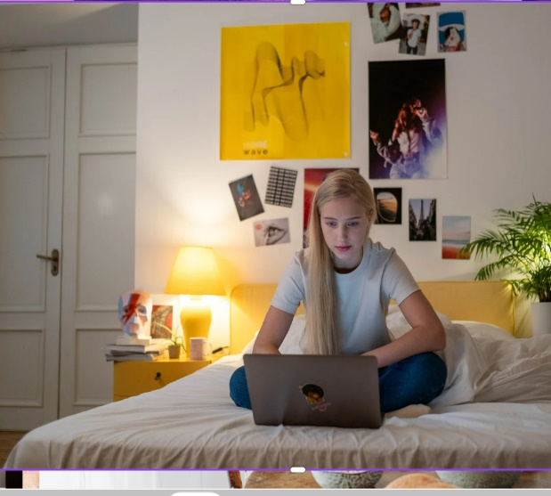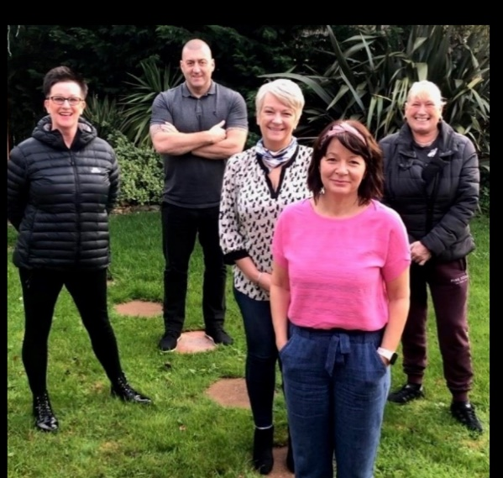

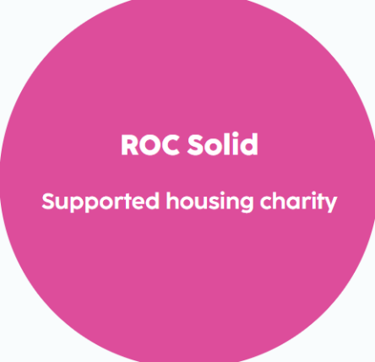

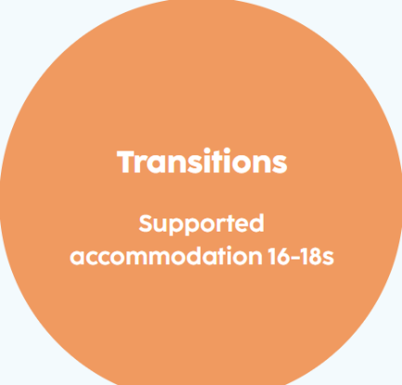



Compliments

& complaints

At The Hawthorns we actively seek the views of young people, and their families, to help us to improve our services. We treat complaints, comments and compliments seriously. Information regarding how to make a complaint is recorded in the Young People’s Guide which is received on admission. Complaints in the first instance can be made to the Registered Manager, by contacting her via email at [kaylie.Mullin@rocgroup.org.uk](mailto:kaylie.Mullin@rocgroup.org.uk) or telephone 01325 310009.

Young people are made aware of the function of independent advocates, NYAS. Every young person is given contact information for this organisation.

We usually try to settle any issues locally, using restorative approaches; this is generally the most effective way of resolving any problems between people. We aim to do this in an inclusive way with the young person, their family and social worker, if appropriate.

There are times, however, when it is helpful for someone outside of the home to have a more independent view. If this is the case a more formal process may be followed, using the framework set out in The Hawthorns Complaints Procedure. Where a complaint cannot be resolved internally, an independent Investigating Officer from a company such as ‘The Children’s Society’ will be appointed to look into the issue.

Complaints and representations will be recorded in Charms, along with actions taken, the outcome and the lessons learnt. Our complaints are monitored by the Responsible Individual.

Copies of our complaints, procedure can be obtained from:

ROC Group Ltd

Hope House

Burnhope

Newton Aycliffe

County Durham

DL5 7ER

 Telephone number: 01325 310009

Email: [info@rocgroup.org.uk](mailto:info@rocgroup.org.uk)

Complaint

contacts

**INVESTING IN CHILDREN:** Tel: 0191 3729200

Email: iiccic@outlook.com

**NYAS:** FREEPHONE 0808 8081001  
Email: [help@nyas.net](mailto:help@nyas.net)

**THE CHILDREN’S RIGHTS COMMISSIONER:**

The Office of the Children’s Commissioner

Sanctuary Buildings

20 Great Smith Street

London

SW1P 3BT

Freephone: 0800 528 0731

Tel: 020 7783 8330

Email: [info.request@childrenscommissioner.gsi.gov.uk](mailto:info.request@childrenscommissioner.gsi.gov.uk)

**OFSTED:** Young people, Parents, Social Workers or Team members can also complain directly to

Ofsted

Piccadilly Gate

Store Street

Manchester

M1 2WD

Tel: 0300 123 1231

If you would like to see a copy of our policies and procedures, please contact Lynn Cunningham on 01325 310009 or info@rocgroup.org.uk.

